PART 1 - SQL Queries to retrieve data:

- Select all clients who borrowed books:

SELECT DISTINCT Client.ClientID, Client.ClientFirstName, Client.ClientLastName
FROM Client
INNER JOIN Borrower ON Client.ClientID = Borrower.ClientID;

- Select all books borrowed by borrowers, order by borrow date:

SELECT Book.BookID, Book.BookTitle, Borrower.BorrowDate
FROM Book
JOIN Borrower ON Book.BookID = Borrower.BookID
ORDER BY Borrower.BorrowDate;

- Select all books and include the author's first and last name:

SELECT Book.BookID, Book.BookTitle, Author.AuthorFirstName, Author.AuthorLastName
FROM Book
JOIN Author ON Book.AuthorID = Author.AuthorID;

- Insert a new client with an occupation of pilot:

INSERT INTO Client (ClientFirstName, ClientLastName, ClientDOB, Occupation)
VALUES ('Zakaria', 'Benmoulay', '1986-09-02', 'pilot');

Part Two - Database Normalization:

The database structure provided in the second part of the assignment or the 5 tables (Produce, Animal products, Grains, Suppliers and Purchases) include few issues that don’t adhere to normalization principle.
To start the process of third form of normalization, we have to make sure that the databases is on 1NF and 2NF and identify the anomalies in the current structure.
- Identification of Dependencies:
Upon examination of the tables, several issues pop out which I will briefly describe;

  - The Produce, Animal Products and Grains tables share redundant structures, specifically the columns ITEMID, SUPPLIERID.
Assuming ITEMID is the primary key, the following columns (PLUCODE, PRODUCENAME, TYPE, STOCKQTY, NEXTDELIVERY) depends on it.
  - LASTDELIVERY, SPECIALTY, ACTIVE depends on the SUPPLIERID in the Suppliers Table

  - In the Purchases table, TOTALBOUGHT, TOTALSOLD, TOTALREV, MARGIN depends on ITEMID as well which violates 3NF.

Now that we highlighted the main anomalies of the structure presented in the second part of the assignment, time to tackle them start the process of normalization.

- NECESSRY STEPS TO TRANSFORM TO 3NF:

To achieve the 3NF principle, we need to carefully address the partial dependencies and remove redundancies and ambiguities.
- ELIMINATE REDUNDANCIES:

Since the Produce, Animal Products, and Grains tables are almost identical except for a few attributes, we can resolve this issue by creating a simple table and let’s call it ITEMS Table.

TABLE STRUCTURE FOR ITEMS
COLUMN_NAME | DATA_TYPE
ITEMID | CHAR(5)
PRODUCTNAME | CHAR(15)
ITEMCODE | VARCHAR(5)
CATEGORY | CHAR(10)
STOCKQTY | NUMBER (4,2)
NXTDELIVERY | DATE
TYPE | CHAR(10)

- ELIMINATE AMBIGUITY:

One of the reasons we removed SUPPLIERID from the ITEMS table is create a simple and more robust relation between the items and the suppliers and we are going to call it ItemSupplier.

TABLE STRUCTURE FOR ItemSupplier

COLUMN_NAME | DATA_TYPE
ITEMID | CHAR (5)
SUPPLIERID | CHAR(10)

- UNCLATTER THE PURCHASES TABLE:

Let’s split the Purchases tables for more accurate data and eliminating transitive dependencies as a process of Normalization 3NF. We create two tables (QUANTITY Table and MARGIN table) where ITEMID is a primary key and foreign key to relate between the tables.

TABLE STRUCTURE FOR QUANTITY

COLUMN_NAME | DATA_TYPE
ITEMID | CHAR (5)
TOTALBOUGHT | NUMBER(8,2)
TOTALSOLD | NUMBER(8,2)

TABLE STRUCTURE FOR MARGIN

COLUMN_NAME | DATA_TYPE
ITEMID | CHAR (5)
TOTALREV | NUMBER(10,2)
MARGIN | NUMBER(10,2)

We can keep the Suppliers table as is since it’s already in a good structure and in line with 3NF standards.

Now that we finished our transformation to the new schema, our “new“ database is well structed and more efficient than the old one. This new schema will offer several advantages including:
Redundancy reduction: eliminating duplicate attributes in Items the previous tables.

Flexibility: The new schema is more adaptable to future changes, weather financial aspect or business strategy.

Final thought

in this second part of the project, we re-structured a relational database for a product management system using NORMALIZATION PRINCIPLE (3NF) for a better schema that help the system efficiency, flexibility and scalability.

We managed to reduce redundancy, and improve the structure for a future proof ready in case of financial or business changes.

References

Study.com: Computer Science 107 – Relational Database design course.

Study.com: Computer Science 107 – Relational Database Model course.

Part Three - Develop an ERD - Entity Relationship Diagram

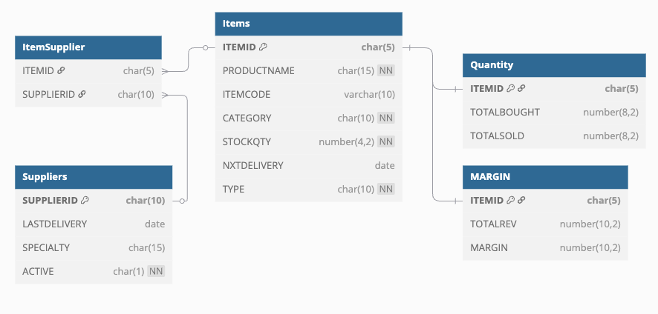

I used dbdiagram.io to make this diagram.

