Zakaria Benmoulay

Computer Science 307 - Assignment 2: Designing UML Diagrams

UML CASE DIAGRAM:
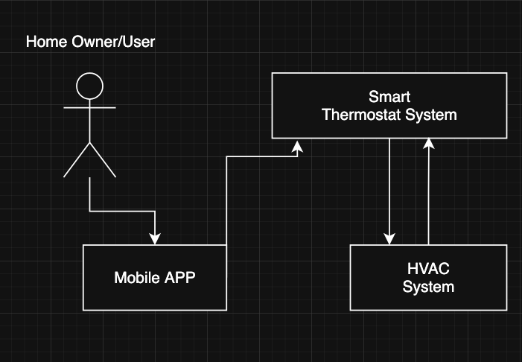
The UML above shows the home owner/user (Actor) interacts with the smart thermostat using the app on his phone or tablet.

System Components:
- Home Owner/User: The human operator who interacts with the system.
- Mobile APP: The user interface that allows remote control and monitoring.
- Smart Thermostat System: The central control unit that manages the HVAC operations.
- HVAC System: The actual heating, ventilation, and air conditioning equipment.

UML CASE DIAGRAM:
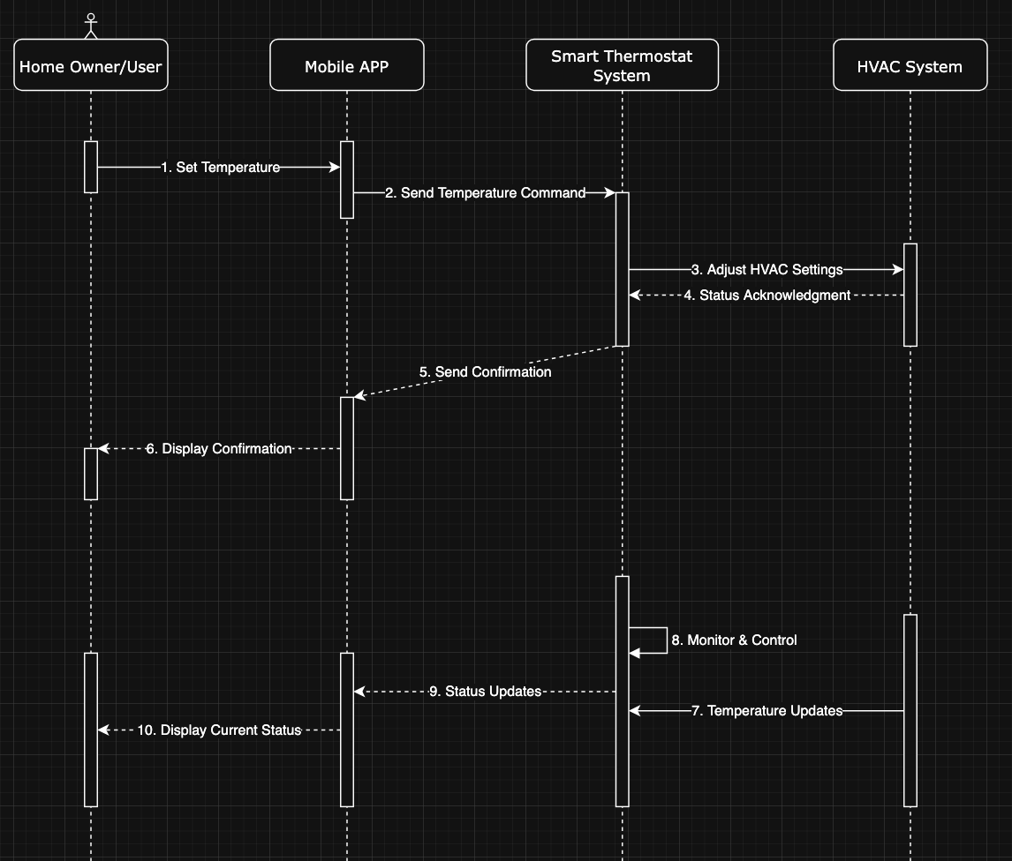

The diagram shown above shows the following:
- Home owner or the user
- The mobile app ( phone/tablets etc.)
- Smart Thermostat system (google nest/ecobee etc.)
- HVAC System
1 – The user adjusts the temperature on the electronic device via the app
2 – The app sends the commands to the Thermostat System
3 – The Thermostat adjust accordingly the HVAC
4 – The HVAC acknowledge the change and send back the confirmation
5 – Thermostat send the confirmation
6 – Confirmation displayed on the electronic device
7 – HVAC keep monitoring and sending updates to the thermostat
8 – Thermostat monitor and control the temperature
9 – Thermostat send status and updates to the electronic device
10 – Mobile app keep up the updates and display them to the user

UML Deployment DIAGRAM:

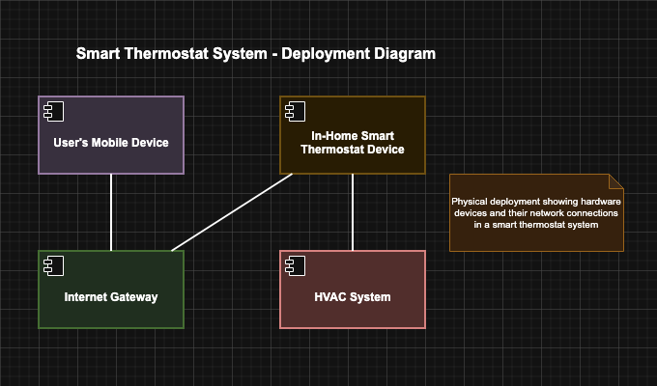

This is a UML deployment diagram that illustrates the physical architecture and network topology of a smart thermostat system. It shows actual hardware devices and how they communicate with each other.
The communication flow works as follow:
Users can control the system remotely through their electronic devices via the internet gateway, which then communicates with the thermostat that directly controls the HVAC system.

