Zakaria Benmoulay

Computer Science307 - Assignment 3 - Components & User Interface Design

Data Flow Diagram:

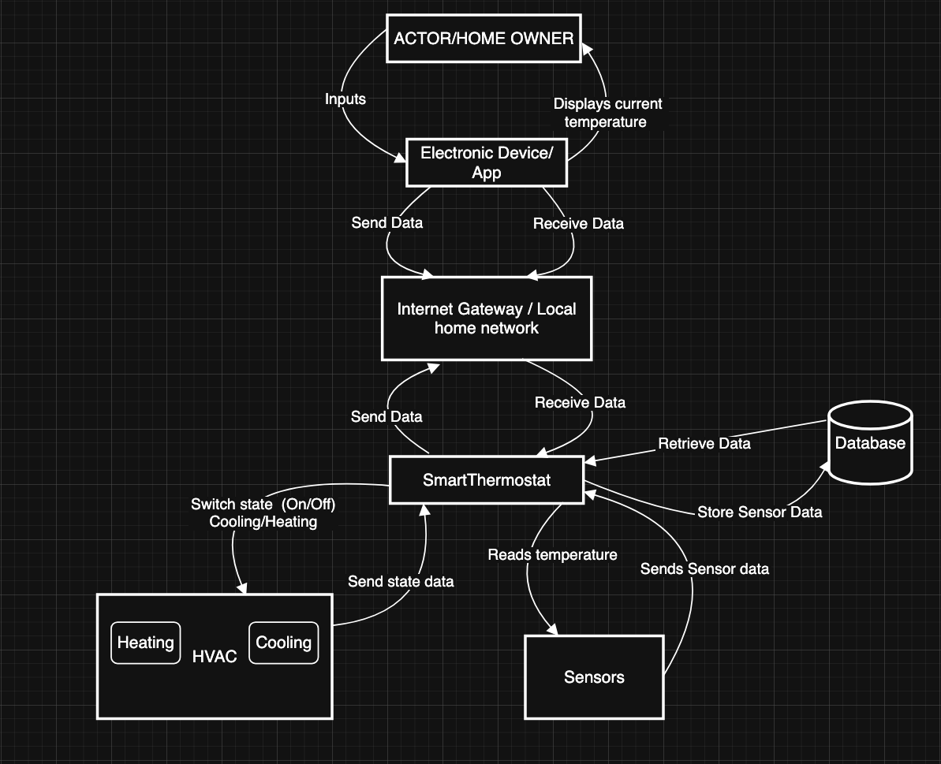

This diagram illustrates the data flow between the Home Owner and the Smart Thermostat System, which is comprised of several key components that work together.
The main flow is:
- The Actor/Home Owner interacts with an Electronic Device or App to view the current temperature and provide inputs.
- This device communicates over the Internet Gateway / Local Home Network to send and receive data.
- The network connects to a central Database which stores and retrieves data.

- The core of the system is the Smart Thermostat, which performs several key functions:
- It reads temperature from Sensors.
- It sends sensor data to be stored.
- It switches the state (On/Off, Cooling/Heating) of the HVAC system.
- It also sends state data and receives data from the network/database.
In summary, the diagram shows how a user's command flows through a network to a database, which instructs the smart thermostat to control the HVAC system based on data it collects from sensors.

State Diagram:
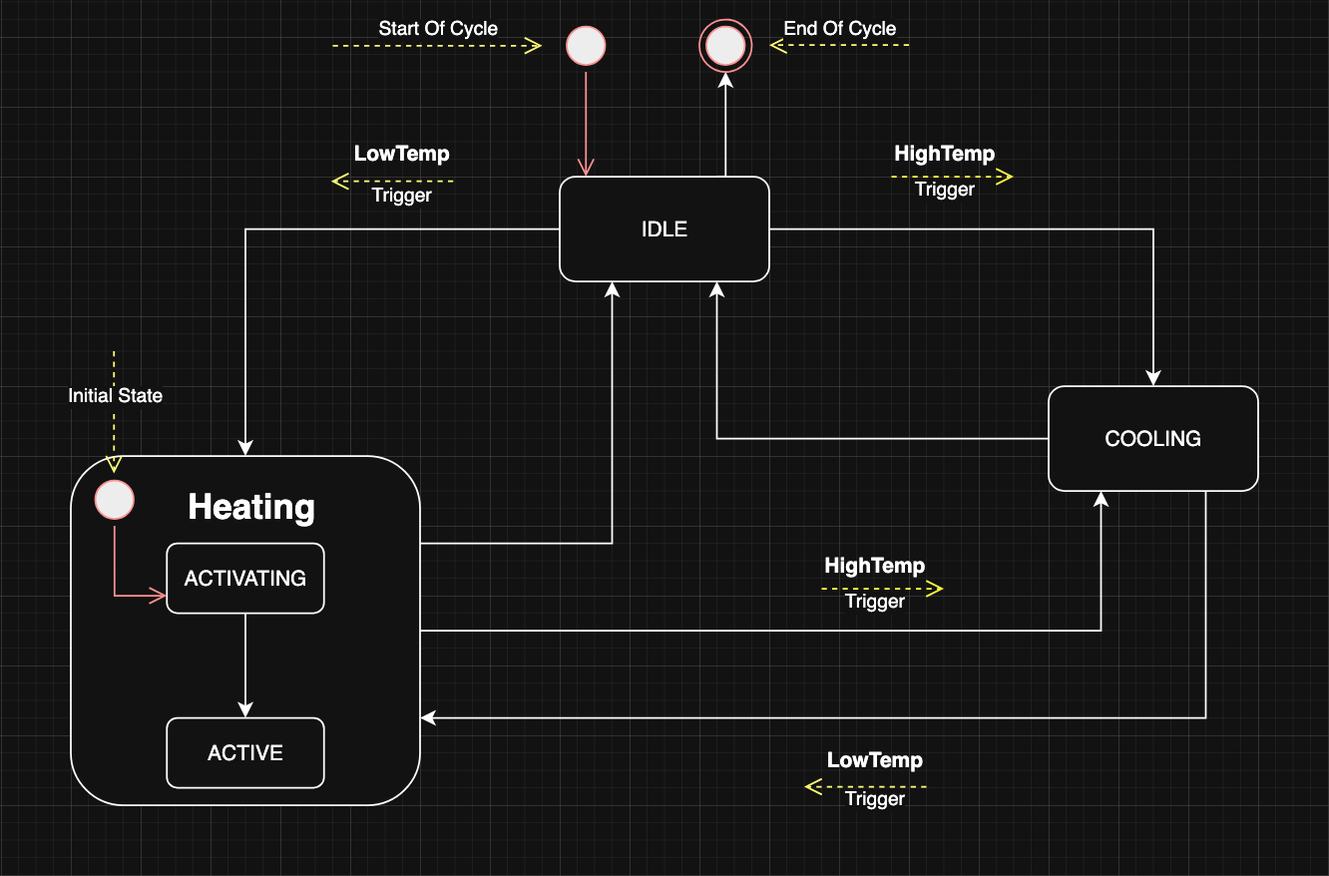

In this State diagram we see that the thermostat control system begins in an initial state before automatically transitioning to Idle, where it remains inactive. When the environment becomes too hot or too cold, it transitions to the Cooling or Heating state. The Heating state contains nested sub-states: it first enters an Activating phase, then transitions to Active. Both Heating and Cooling states return to Idle once the desired temperature is reached. The system may also proceed to a final state from Cooling if it becomes too cold. This design illustrates state transitions, nested states, actions during transitions with a start of cycle / end of Cycle.
Activity Diagram:
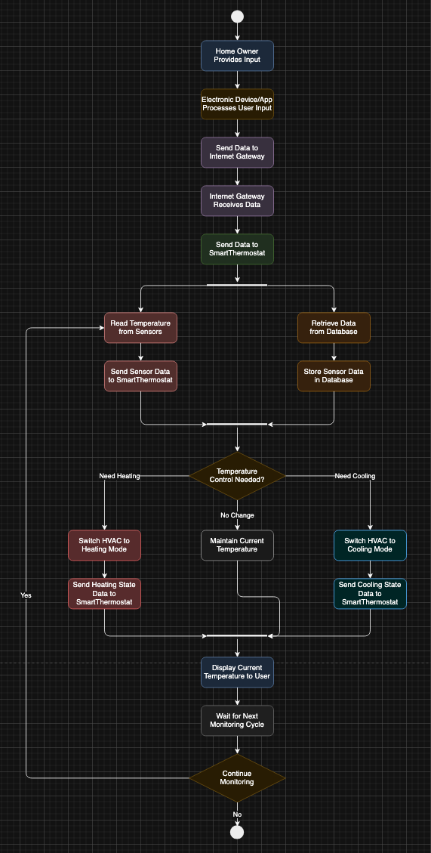
The Activity diagram illustrates the workflow starting from the Actor setting the thermostat through a device or an app, which processes the command and sends it via the internet ( https/ local home http) via the internet gateway. The system then executes parallel activities: reading temperature data from sensors and retrieving/storing data in the database. Based on the collected sensor data, the system makes a decision about temperature control needs - if heating is required, it switches the HVAC to heating mode; if cooling is needed, it activates cooling mode; otherwise, it maintains the current temperature. After executing the necessary actions, the system sends data to display the current temperatures to the user, creating a continuous automated and monitored cycle until the system is shut down.

Simple User Interface:

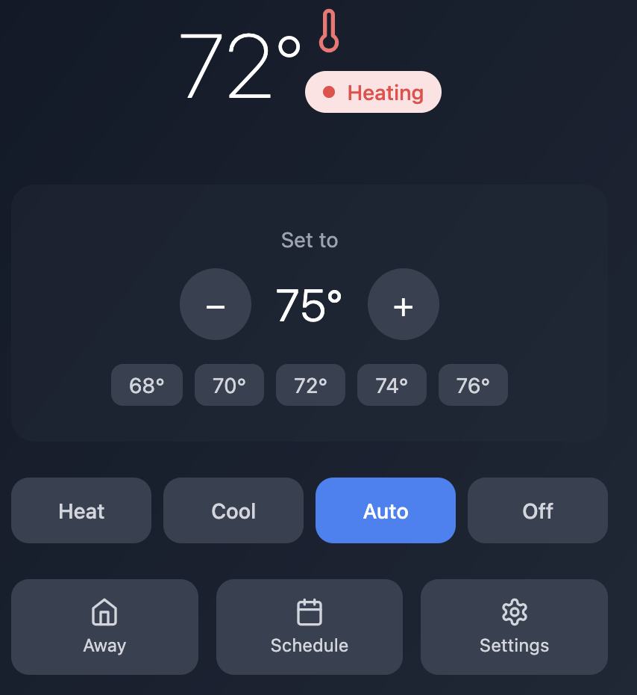

The interface is pretty simple and intuitive, prioritizes the most common user tasks (adjusting temperature, changing modes) while keeping advanced features accessible but not cluttered. The dark theme with high contrast ensures readability, and the responsive design works well on both wall-mounted devices and mobile devices.

