Data Structures and Algorithms II - C950
Performance Assessment:
TASK 2 - WGUPS Routing Program Implementation

Student Name: Zakaria Benmoulay
Student ID: 012498637
Course: Data Structures and Algorithms II - C950
Submission Date: 27 March 2026

D1. Screenshot at 09:00:
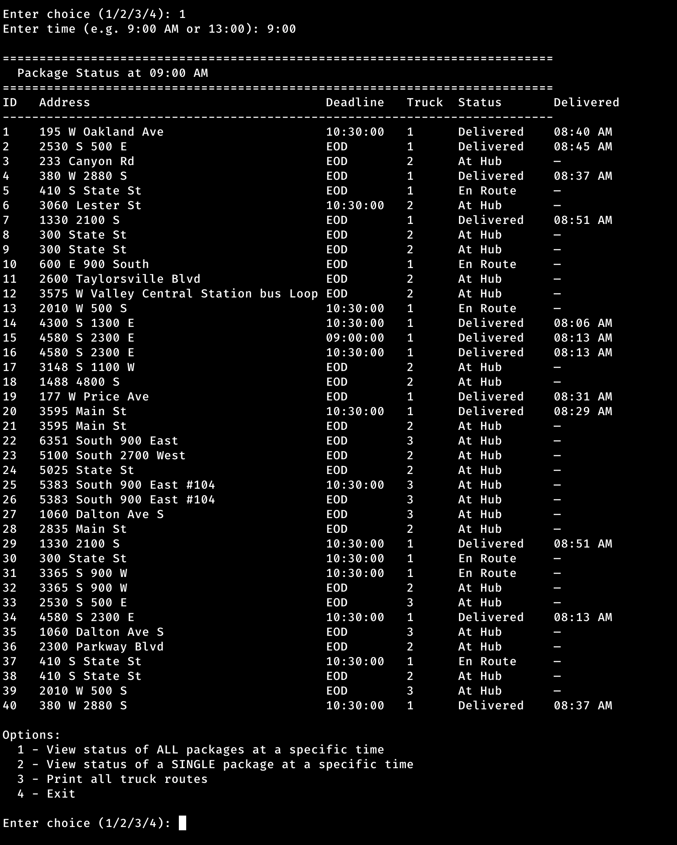

D2. Screenshot at 10:00:
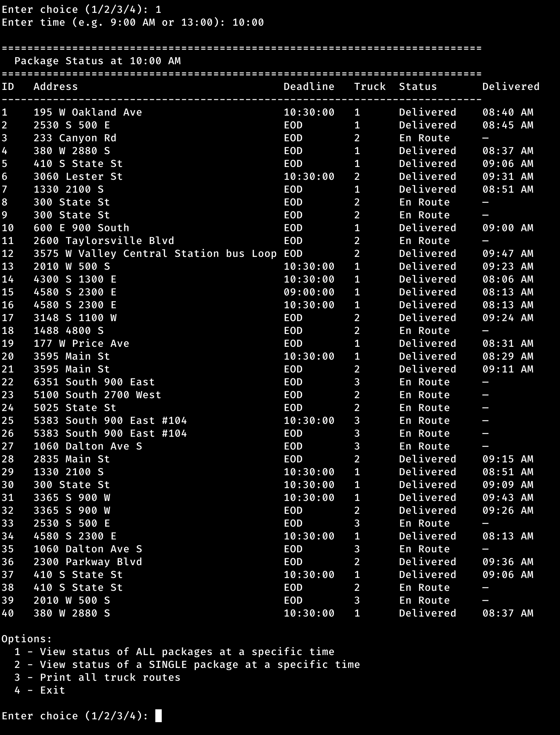

D3. Screenshot at 12:30:
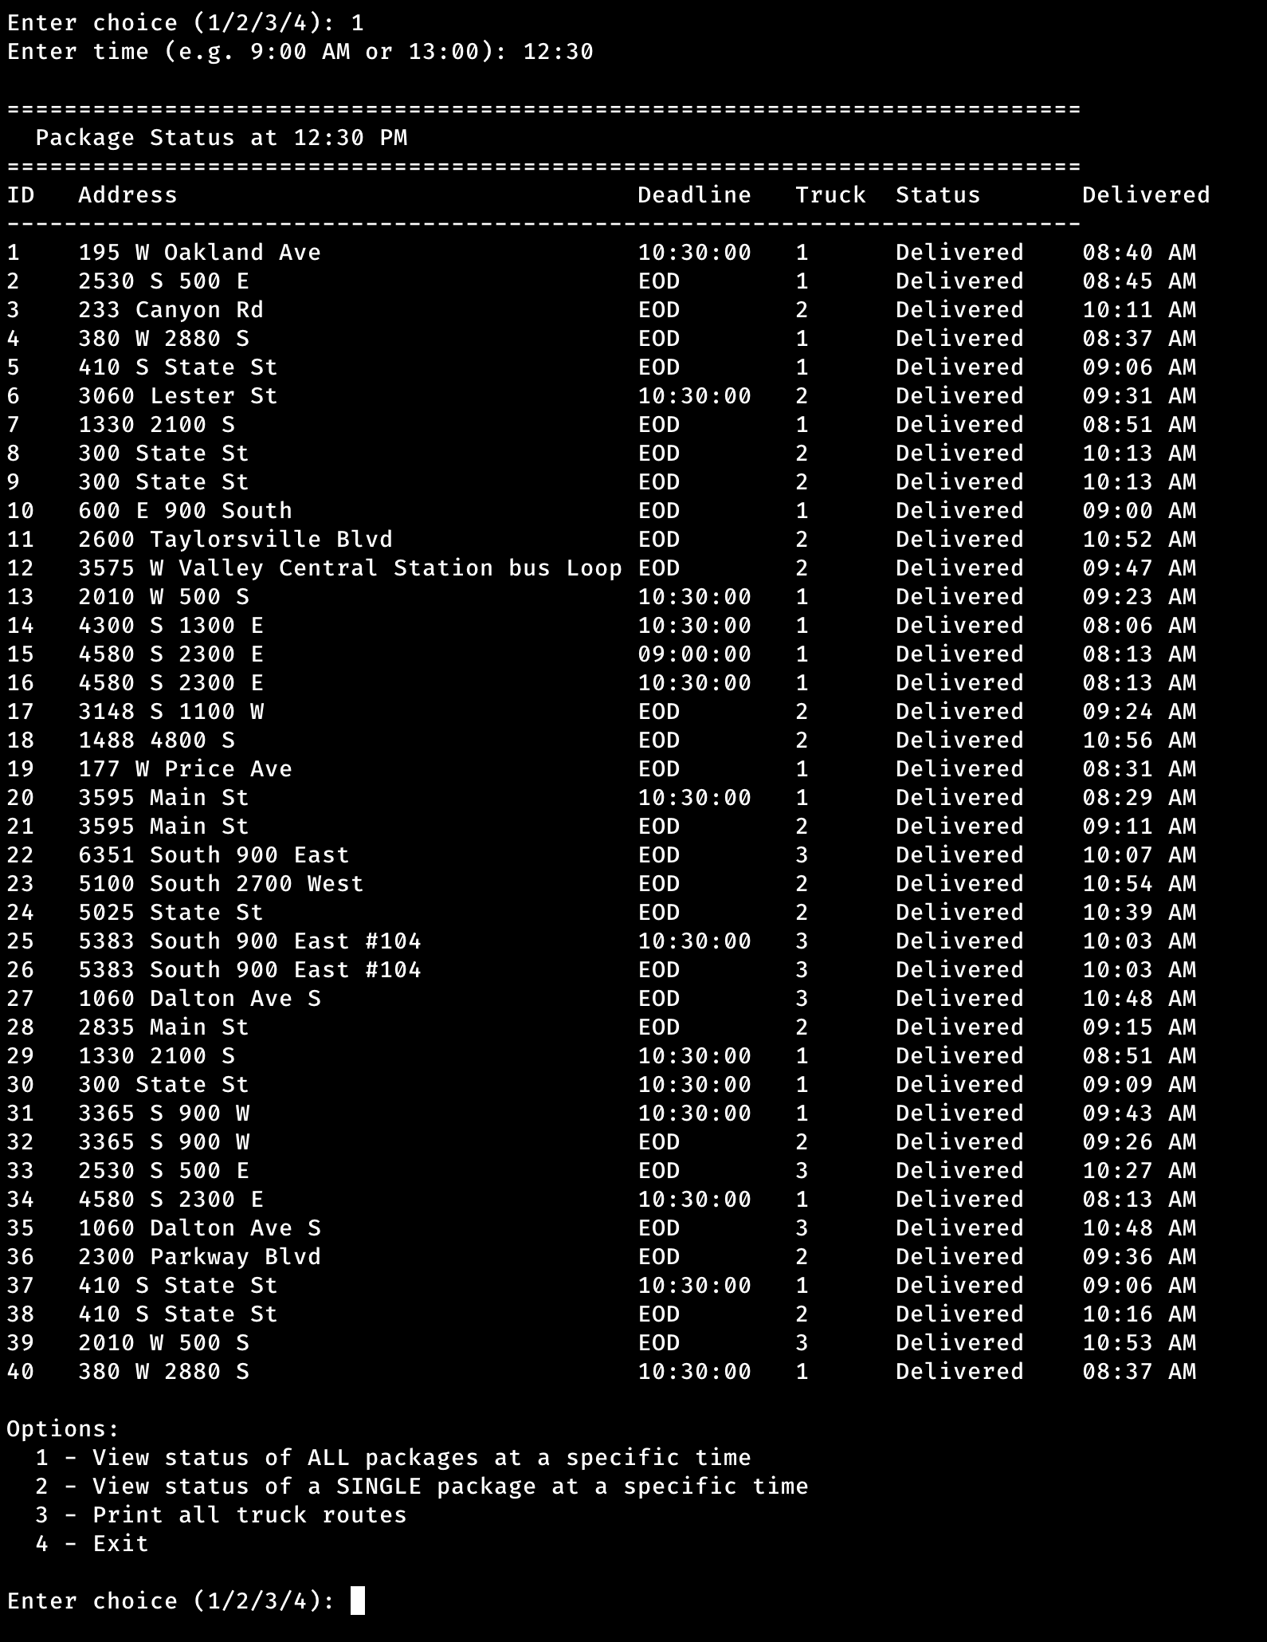

E. Screenshot TOTAL MILEAGE:
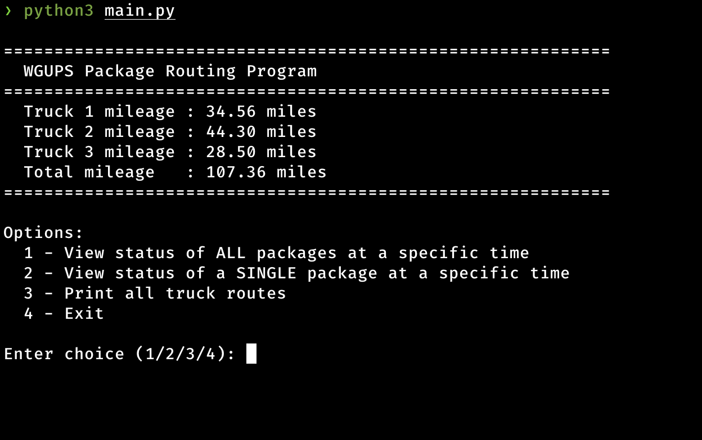

E. Screenshots when you press 3 and exit:
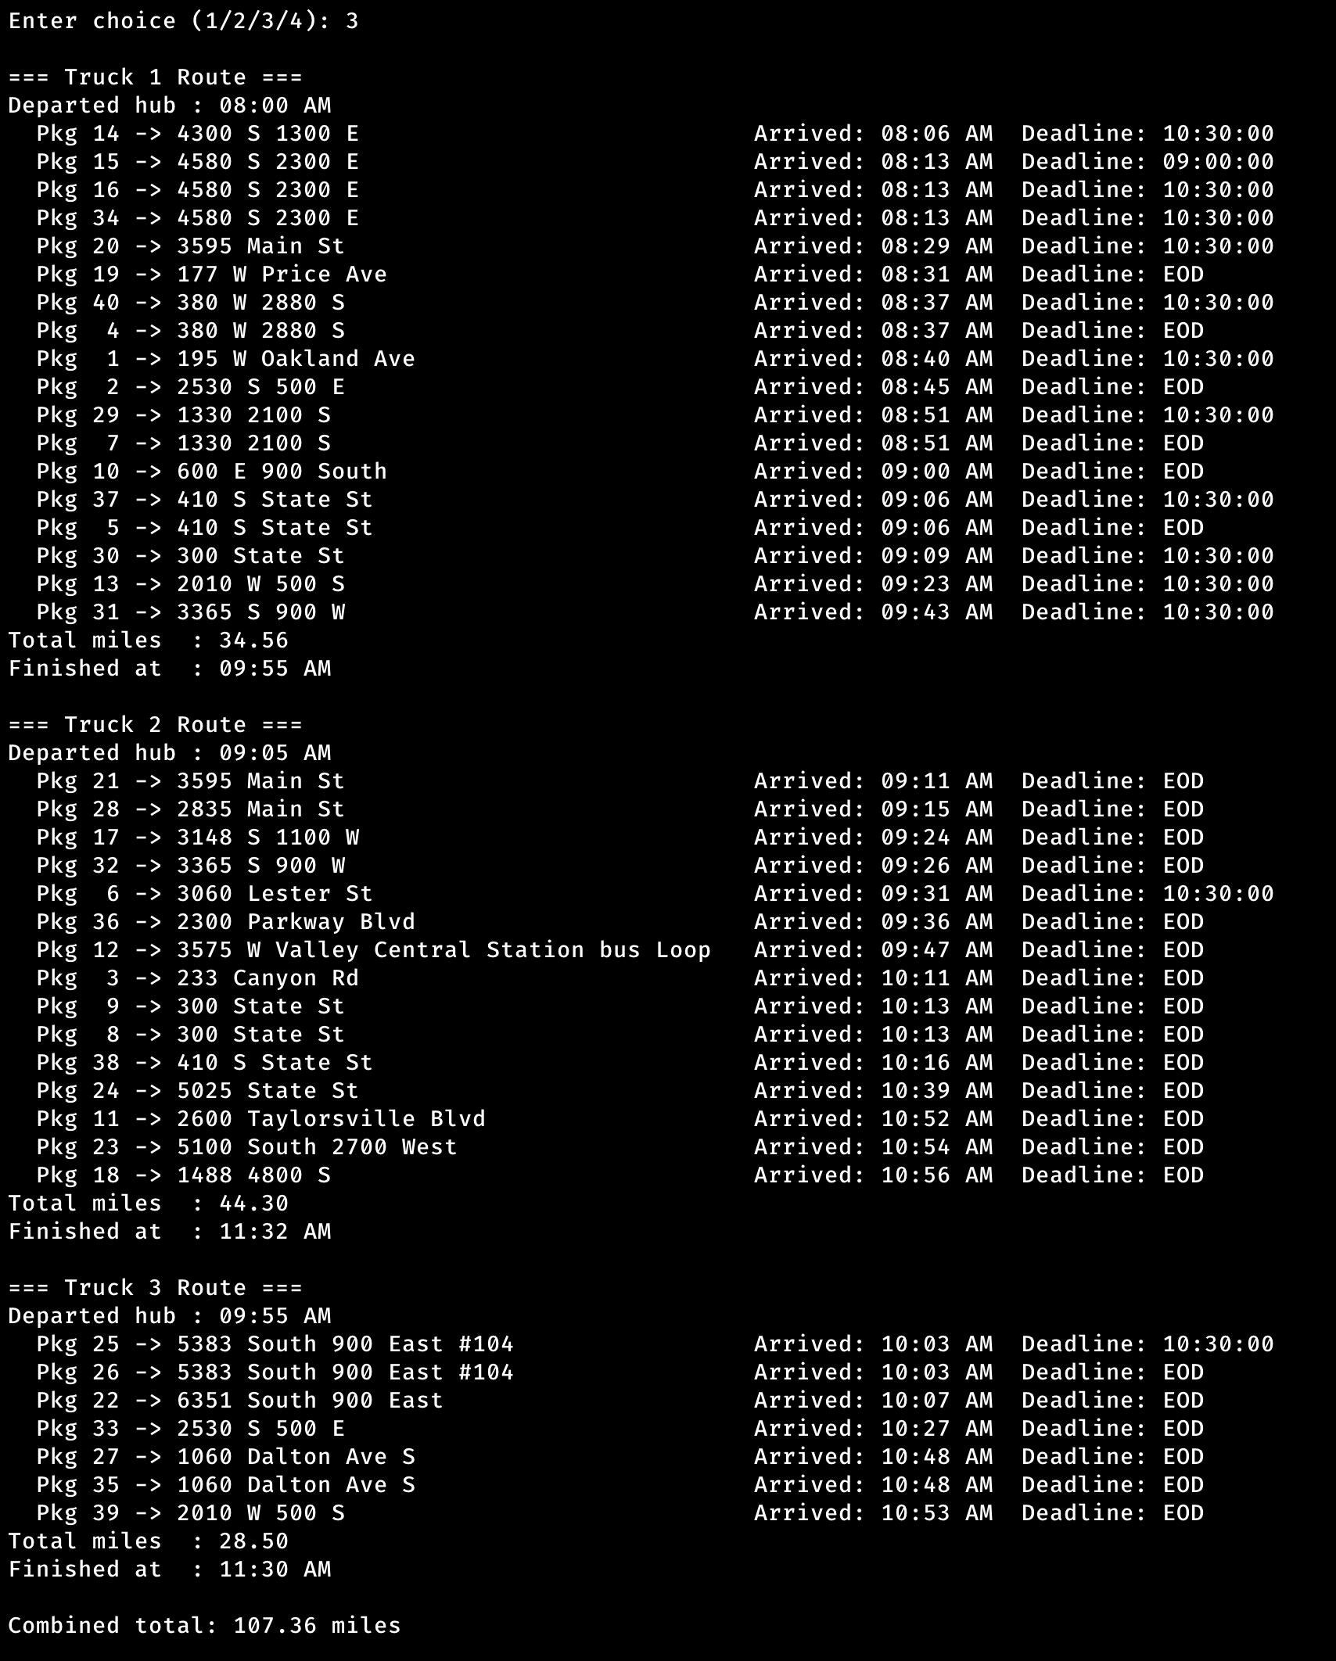
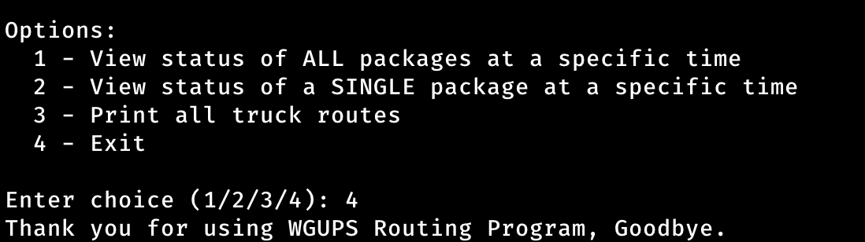
F. Algorithm Justification
F1. Strengths of the Nearest Neighbor Algorithm
In this project I used the nearest neighbor algorithm to create my WGUPS routing delivery program, taking advantage of the two clear strengths of solution represented as follow:
The first strength is its simplicity and speed. The algorithm makes routing decisions without any complex look-ahead or backtracking. It simply picks the closest unvisited address at each step, which makes it very easy to implement, and fast enough to complete all three truck runs in milliseconds as the overall algorithm runs in O(n²) time. For a fixed dataset of 40 packages with constrains, the nearest neighbor algorithm is a practical first choice for WGUPS routing delivery system.
The second strength is that it is self-adjusting, meaning, rather than following a fixed predetermined route, the algorithm recalculates the best next stop at every step depending on the track’s current location and the remaining undelivered packages dynamically.
F2. Verification That the Algorithm Meets All Requirements
The nearest neighbor algorithm, as implemented in this program, meets every requirement outlined in the scenario:
- All 40 packages delivered as the program loop runs until the packages list is empty.
- Constrained packages like packages 6, 28, and 32 are assigned to Truck 2 which does not depart until 9:05 AM, and also packages 3, 18, 36, and 38 are explicitly assigned to Truck 2 in the loading section.
- The truck speed constrained was respected and set to 18 in truck.py and was used for all travel time calculation.
- All deadlines were met as the program was tested and confirmed that all packages were delivered and on time.
- The total combined mileage for all three trucks came to 107.36 miles, well under the 140 miles limit.
- Each truck was manually loaded with no more than 16 packages in the main.py before the algorithm runs.
- Package 9 wrong address was resolved by a method in truck.py; holds the wrong address until 10:20 AM, then switches to the corrected address automatically.

F3. Two Alternative Algorithms
The 2-opt algorithm and Dijkstra's shortest path could have both used in the WGUPS routing delivery system and meet all the project requirements.
The 2-opt algorithm is a local search improvement heuristic that starts with an existing route and repeatedly swaps two edges if the swap produces a shorter total distance, continuing until no further improvement can be found [1].
Dijkstra's shortest path algorithm finds the shortest path between two locations by evaluating all possible paths from a starting point and selecting the one with the lowest cumulative distance [2].
F3a. How These Algorithms Differ from the Nearest Neighbor Algorithm
The 2-opt algorithm:
The 2-opt algorithm is different from the nearest neighbor algorithm because it is an improvement algorithm rather than a construction algorithm. The 2-opt algorithm starts with a complete route and then improves it by reversing segments resulting in reducing total distance [3].
Dijkstra's shortest path:
The difference between the nearest neighbor algorithm and Dijkstra's shortest path is in how it evaluates paths. The nearest neighbor algorithm only looks at the distance from the truck's current location to pick the next stop. Dijkstra's algorithm, on the other hand, uses a graph where edges between locations are assigned numerical distance values, and it calculates the shortest path from a starting point to every other vertex in the graph. This means it considers all possible paths rather than just making a local decision at each step [4].
G. What I Would Do Differently
If I could do this project again, I would develop a method that would automatically sort packages based on their constraints instead of hardcoding and manually loading the packages to the trucks. This would make the solution more robust and scalable in case of the number of packages increases in the future and reduce human error.
I would have developed a web-based user interface, using HTML and CSS connected to the python backend, with real-time tracking, trucks movements displayed on the map, and delivery status checker. This way the user can see the full picture of the solution.

H. Data Structure Verification
The chaining hash table I used in this program meets all the requirements of the WGUPS scenario. It stores all 40 packages using the package ID as the key, with each entry holding all the required data components, delivery address, deadline, city, zip code, weight, notes, status, and delivery time.
It also includes an insertion function that takes the package ID as input and stores all the data, while the lookup function takes the package ID and return everything associated with it. During the simulation the program looks up each package by ID to update its status and delivery time.

All packages were delivered within the expected deadlines, and the total of the all trucks mileage was under the 140 miles limit at only 107.36 miles.
H1. Two Alternative Data Structures
Two other data structures that could meet the same requirements in the scenario are a binary search tree (BST) and a direct-access array.
A binary search tree stores key-value pairs in a tree structure where each node’s key is greater than all keys in its left subtree and less than all keys in its right subtree. Lookup, insertion, and deletion run in O(log n) average time for a balanced BST.

A direct-access array stores values at index positions corresponding directly to their keys. Since package IDs are integers from 1 to 40, an array could store each Package object at the index equal to its package ID. Lookup and insertion would both be O(1) with no hashing required.
Both of these alternative Data structures could meet the WGUPS requirements.
H1a. How These Data Structures Differ from the Hash Table
Binary search tree:
The binary search tree is different from hash table in how it retrieves data. BTS organizes entries by key comparison along a tree path, resulting in O(log n) lookup, which makes slower than hash table where it maps keys to bucket indices using hash function with an O(1) lookup. BST also provides a natural sorted ordering of keys, which the hash table does not. The hash table also handles collisions through chaining, which has no equivalent in a BST since each key occupies a unique node.
A direct-access array:
The difference between the direct-access array and a hash table is that the direct-access array does not require a hash function, meaning, the package id is used directly as the array index, making lookups a single O(1) array access with no collision handling and no bucket scanning. On the other hand, direct-access requires pre-allocating space for the entire key range, which is a waste of memory. The hash table is also more flexible and can grow dynamically where the direct-access array cannot.
I. Resources:
[1] The Approximation Ratio of the 2-Opt Heuristic for the Euclidean Traveling Salesman Problem | Arxiv
https://arxiv.org/abs/2010.02583
[2] [4] Cormen, T. H., Leiserson, C. E., Rivest, R. L., & Stein, C. (2022). Introduction to algorithms (4th ed.). MIT Press.
[3] Brodowsky, U. A., & Hougardy, S. (2021). The approximation ratio of the 2-opt heuristic for the Euclidean traveling salesman problem | https://arxiv.org/abs/2010.02583

Respectfully submitted,

Zakaria Benmoulay
012498637

