Artificial Intelligence Optimization for Computer Scientists - D682
Performance Assessment:
TASK 3 - AI Model Optimization

Student Name: Zakaria Benmoulay
Student ID: 012498637
Course: Artificial Intelligence Optimization for Computer Scientists - D682
Submission Date: 20 February 2026

Overview: In this submission, I developed a narrative analysis report to explore urban air quality data, identify key patterns and interpret the outputs of an optimized algorithm.

Data Exploration and Analysis

A1. Distribution of Key Variables:
The DQN1 Dataset contains 1000 daily observations containing 35 weather conditions, air pollutant related variables and the derived health risk score for an urban environment. After an exploratory data analysis, three key variables were selected for detailed distribution analysis: PM2.5 concentration, carbon dioxide (CO2), and Health Risk Score [1].

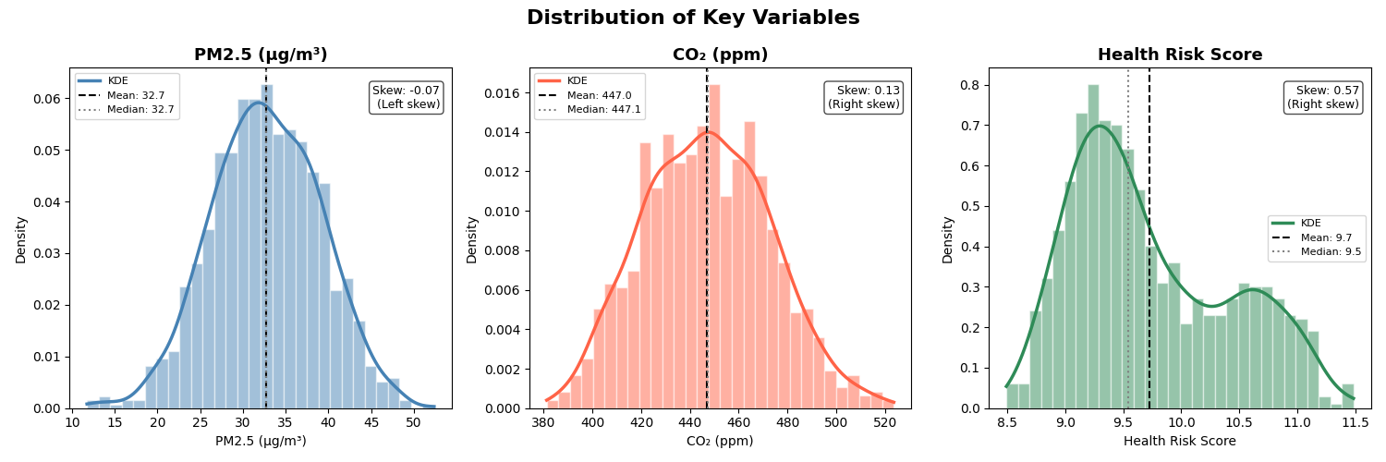

Figure 1 - Histograms showing the distributions of PM2.5, CO₂, and Health Risk Score.

PM2.5 Concentration range from 11.74 to 52.38 micrograms per cubic meter (µg/m³), with a mean of 32.74 µg/m³ and standard deviation of 6.31. As shown in Figure 1, the distribution is closely bell-shaped with a negligible left skew (skew = -0.07), meaning the data is nearly symmetric with a very slight lean toward lower values.

Carbon Dioxide (Co2) values ranges from 381 to 524 ppm, with a mean of 446.96 ppm and standard deviation of 25.91. Figure 1 reveals a mild right skew (skew = 0.13), indicating a slight elevated reading likely due to periods of atmospheric stagnation that trap pollutants near the surface, exceeding the pre-industrial baseline of approximately 280 ppm, underscoring the chronic presence of this pollutant in modern urban environments [2].
Health Risk Score ranges from 8.49 to 11.49, with a mean of 9.7 and a median of 9.5 and a standard deviation of 0.68. Figure 1 reveals a right skew (skew = 0.57) and a bimodal KDE curve. This bimodal pattern indicates that there are two distinct risk regimes in the data: typical low-risk days and a separate cluster of high-risk days, likely driven by compounding weather factors like high heat index. Recognizing this distinction is important for designing models and setting thresholds for health alert systems.

A2. Underlying Patterns in the Data
By examining the data and scatter plot visualization, two distinct meaningful patterns emerge that help explain what actually driving health risk in this urban environment.

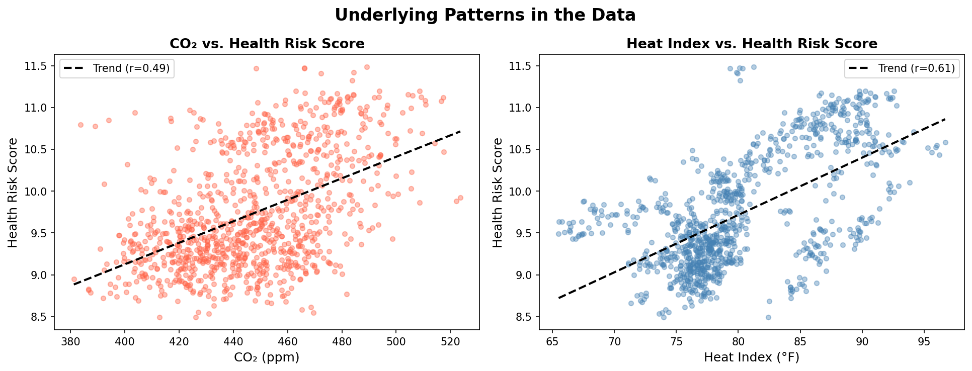

Figure 2. Scatter plots illustrating two key underlying patterns: CO₂ vs. Health Risk Score (left) and Heat Index vs. Health Risk Score (right).

Co2 Concentration and Health Risk Score show a positive linear relationship. The Pearson correlation between Co2 and Health Risk Score is r = 0.49 [3], indicating a moderate positive association. According to the DQN1, as the Co2 increases, the Health Risk Score rises accordingly. For example, days with CO₂ in the top quartile (above roughly 460 ppm) have an average Health Risk Score of 10.24, compared to 9.36 for days in the bottom quartile (below about 420 ppm)—almost a full standard deviation difference. This aligns with prior research linking elevated CO₂ to cognitive effects indoors and inflammatory responses outdoors [4].

Heat Index is the strongest meteorological driver of Health Risk. Among all meteorological variables, Heat Index shows the strongest correlation with Health Risk Score (r = 0.61). Days in the top quartile of Heat Index (above about 95°F) have an average Health Risk Score of 10.38, compared to 9.32 for days in the bottom quartile—a difference of over 1.5 standard deviations. This suggests that heat stress adds to the physiological burden from air pollutants. High heat index days often coincide with stagnant air, which traps pollutants near the surface and amplifies their impact on health outcomes.

A3. Hypothesis
Based on the two patterns identified above, I propose the following hypothesis:
Days that have high Co2 Concentrations and High Head Index values will lead to significantly higher Health Risk Scores due to a combination of heat stress and environmental pollutants.
This hypothesis directly connects the observed strong correlation of both Co2 (r=0.49) and Heat Index (r=0.61) with the Health Risk Score. The idea is that extreme heat can put stress on the body, making harder to cope with air pollutant, while higher Co2 levels often is linked to cognitive effects indoors and inflammatory responses outdoors.

Interpretation of Model Outputs
B1. Performance Metrics Analysis
After comparing the three algorithms; Decision Tree, Random Forest and Gradient Boosting, the optimized Gradient Boosting model tune with Randomized Search emerged as the best performer. I used the Root Mean Squared Error (RMSE), which measures how far off predictions are on average, and R-Squared(R2), which measures how much of the variation in Health Risk Score the model successfully explains. The table below summarizes the results:
Metric | Result
Model | Gradient Boosting (Random Search)
Root Mean Squared Error (RMSE) | 0.1104
R-squared (R²) | 0.9731
Score range in dataset | ~3.0 points (8.49 – 11.49)
Average prediction error as % of range | ~3.7%

This optimized model achieved an RMSE of 0.1104 and an R2 of 0.9731, which means this model explains 97.3% of the variation in Health Risk Score on data it had never seen before and with prediction error of 0.11, which conclude that the model not only is performing well, but it’s actually capturing the actual structure of how weather conditions and pollutants come together to produce health risk.

This level of accuracy has real consequences from a decision-making standpoint. A model that can explain 97.3% of the variance means that city officials and public health agencies can trust the model’s predictions when they plan interventions. For example, if the model forecasts a spike in Health Risk Score for an upcoming day, that prediction is reliable enough to justify issuing public advisories and alerting concerned parties to be prepared or take the necessary precautions to limit potential harm. At the same time, if the model predicts that low risk, resources can be allocated elsewhere without the fear of overlooking a dangerous event.

B2. Feature Importance and Model Behavior Insights
Figure 3 shows the feature importance scores from the optimized Gradient Boosting model. This visualization indicates the significance of each feature, making easier to distinguish the most influential ones.

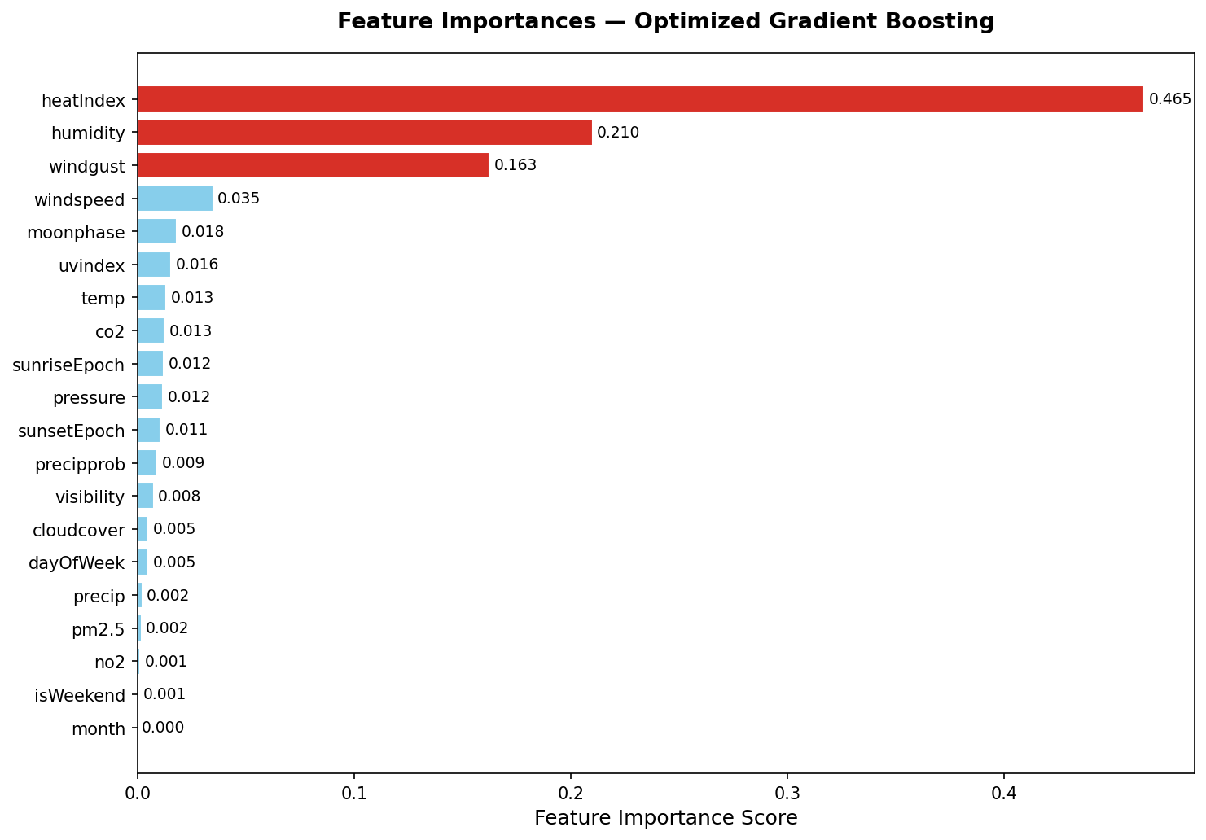

Figure 3. Feature importances from the optimized Gradient Boosting model.

Heat Index (Importance = 0.463): Heat Index is the most influential feature with an impact of 46.3% of the model’s total predictive power. This means that nearly half of the model’s explanation of health risk is tied to how hot it actually feels when humidity is considered alongside temperature, which many public health research agencies confirm; when the air reaches dangerous levels, the body experiences serious stress where the cardiovascular and respiratory systems work harder, making people more vulnerable to both heat-related illness and the effects of airborne pollutants. For health officials, Heat Index forecasts should be the primary trigger for issuing public health advisories.

Humidity (Importance = 0.214): Humidity is the second most influential feature at 21.4%. This feature confirms the Heat Index results, since humidity directly affects perceived heat, but it also plays an independent role. For example, "High humidity can impair the body's ability to cool itself, leading to increased risk of heat-related illnesses such as heat exhaustion and heat stroke" [5], and can contribute to atmospheric conditions that prevent pollutants from dispersing efficiently.

Wind Gust (Importance = 0.156): Wind Gust speed comes at the third place at 15.6% of the model’s importance. While wind is often considered cleansing force for pollutants, strong gusts in an urban environment can redistribute pollutants and particulate matter, pushing poor air quality into new areas.

We also notice that pollutants such Co2, PM2.5 and No2, rank near the bottom of the importance chart (below 1-2%). This doesn’t mean that they are harmless, rather, it tells us that within this dataset (DNQ1), meteorological conditions are dominant drivers of day to day variation in Health Risk Score.

B3. Informing Future Predictions and Strategic Decisions

Heat Mitigation and Urban Planning:
Although traditional pollutant concentrations like Co2, No2, PM.2.5 appear less influential in the model’s importance chart, this does not diminish their long-term importance for public health. Instead, it suggests that emission reductions paired with heat mitigation strategies such as urban greening, can have a great health benefit. According to the U.S Environment Protection Agency (EPA), Green infrastructure like green roofs, tree canopy and vegetation, is an effective approach to cool urban environments, and improve health and comfort in communities. These co-benefits support strategic planning efforts that address both short-term heat risks and longer-term climate resilience goals [7].

Real-Time Early Warning Systems:
The model’s strong performance (RMSE:0.1104, R2:0.9731) and the identification of Heat Index and Humidity as dominant predictors make it well-suited for deployment as a real-time early warning tool. Public health agencies can integrate hourly weather forecast feed into the model pipeline to issue same-day or next-day air quality or heat-related health advisories. For example, the CDC and NOAA’s HeatRisk tool uses local heat forecasts to indicate risk levels and provide guidance accordingly, which helps planners and medical sectors to be well prepared [6].

Iterative Monitoring and Adaptive Policy:
The model’s output can support Adaptive environmental and health risk management by creating a feedback loop between forecasts, actions and outcomes [8]. After implementing interventions such heat advisories or green infrastructure projects, monitoring actual health and environmental results allows planners to evaluate whether those actions reduced Health Risk Scores as predicted, refine the model with the new data, and adjust policies over time. This iterative approach improves long-term decision making, help manage uncertainty, and strengthens frameworks based on real world results.

References:

[1] EDA - Exploratory Data Analysis in Python | GeeksforGeeks
https://www.geeksforgeeks.org/data-analysis/exploratory-data-analysis-in-python/
[2] A Graphical History of Atmospheric CO2 Levels Over Time | EARTH ORG
https://earth.org/data_visualization/a-brief-history-of-co2/
[3] r_regression | scikit
https://scikit-learn.org/stable/modules/generated/sklearn.feature_selection.r_regression.html
[4] Is CO2 an Indoor Pollutant? Direct Effects of Low-to-Moderate CO2 Concentrations on Human Decision-Making Performance | Research Gate https://www.researchgate.net/publication/231176310_Is_CO2_an_Indoor_Pollutant_Direct_Effects_of_Low-to-Moderate_CO2_Concentrations_on_Human_Decision-Making_Performance
[5] How Humidity Affects Our Health | Houston Methodist https://www.houstonmethodist.org/blog/articles/2025/jun/how-humidity-affects-our-health/
[6] How to use the HeatRisk Tool and Air Quality Index | https://www.cdc.gov/heat-health/hcp/clinical-guidance/how-to-use-the-heatrisk-tool-and-air-quality-index.html
[7] Reduce Heat Islands | EPA
https://www.epa.gov/green-infrastructure/reduce-heat-islands

[8] Bridging adaptive management and reinforcement learning for more robust decisions | The Royal Society https://royalsocietypublishing.org/rstb/article/378/1881/20220195/109204/Bridging-adaptive-management-and-reinforcement

Respectfully submitted,

Zakaria Benmoulay
012498637

