D686: Operating Systems for Computer Scientists Study Guide

Goals of Operating Systems
Discuss Goals of Operating Systems (Section 1.5 in Zybooks)

Computer System Organization
Discuss Computer System Storage-device Hierarchy (Section 1.6 in Zybooks)

Windows and Linux Commands
Use your book, additional resources, and the internet to memorize and complete the table:
Operation | Definition | Windows Command  (Command Prompt) | Windows GUI | Linux Command
Change | Change the current working directory to another directory
Create | Create a new named directory
Delete | Delete directory from the path (and deletes all the files and directories nested within the deleted directory)
Move | Move a directory to another
Rename | Rename a file directory
List | List all the file names and other attributes within a specified file name
Find | Find a file or directory by name | Wildcard: *
Locate
Print
Mounting File System
Unmounting File System
Ping
Ifconfig
Display File Contents
Stream Editor for Editing Text

Security Questions
Memorize and complete the following table from Chapter 15 in Zybooks:

Type of Cryptography | Also known as… | Key for Encryption  (Circle one) | Key for Decryption  (Circle one) | Algorithm Used for Encryption (Circle one) | Describe the Cryptography
Symmetric |  | Public / Private | Public / Private | RSA / DES
Asymmetric |  | Public / Private | Public / Private | RSA / DES

What is a man-in-the-middle attack?

What is a logic bomb?

What is a back door?

What is a session hijacking?

What is social engineering?

What is difference between breach of confidentiality and breach of integrity?

What is denial-of-service (DoS)?

How is ransomware different from spyware?

How is Boot Virus different from Rootkit Virus?

What are the differences between a virus and a worm?

What is a trojan horse?

What is a code-injection attack?

Why should developers use a sandbox?

What is a hash?

What is a DDoS attack?

What does defense in depth mean?

Define two-factor authentication?

What is Dropbox?

What can be used to access Dropbox?

There are three types of factors of authentication: something you have, something you know, something you are. Describe and provide an example of each:
- Something you know:

- Something you are (also known as biometrics):

- Something you have:

In cybersecurity, Define the following:
- Symmetric encryption

- Asymmetric encryption

- message-authentication code (MAC)

- Difference between a stream cipher and a block cipher

- Two main techniques for authentication

Access and Capabilities List

What is the difference between access list and capability list. And what does * or c mean in an access list.

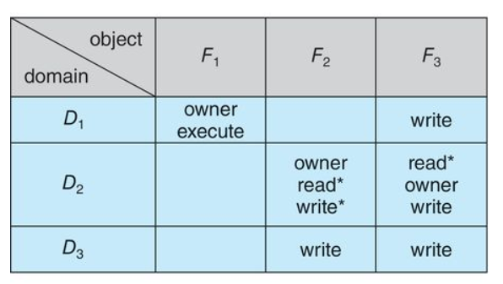
Memory Questions
What is an example of physical memory and its limitations?

What is logical memory and why is it used?

When memory is considered volatile, what does that mean?

When memory is considered nonvolatile, what does that mean?

What is DMA and when is it used?

Paging
Using Chapter 8 in your Zybooks, complete the following table:
Term | Definition | Metaphor
Page Table |  | A “phone book” of where data resides
Page |  | A “page” of a phone book
Page Frame |  | An “ad” of a phone book
Why do we use a page table?

How does a page relate to a logical address space?

How does a page frame relate to a physical address?

Define the following: Logical Address, Logical Address Space, and Physical Address.

Page Replacement
What is a page replacement and page fault rate?

What is the best page replacement algorithm?

Which page replacement algorithm results in the fewest number of page faults?

What is the optimal page replacement algorithm?

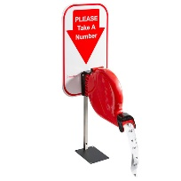
What is the FIFO page replacement algorithm?

What is the LRU page replacement algorithm?

What is the concept of the valid-invalid bit in page replacement?

What is Belady's anomaly?

What is Working-Set Model ?

What is the difference between global and local replacement strategies in allocation of frames?

What is the Page Fault Frequency?

What is thrashing?

Fragmentation
What causes the following types of fragmentation:
Internal:

External:

What is a boot partition?

Draw a diagram showing the user powering up their computer and initiating the boot partition, boot sector, boot kernel, and OS:

In the 50% rule, how much of memory is wasted on average? (Circle one):
- 1/2
- 1/3
- 1/4

Memory Management
Define and draw a picture of memory swapping: | Define and draw a picture of memory compaction:

Segmentation and Segment Tables
What is the difference between a segment table and page table?

Define the following terms using Chapter 8 in your Zybooks:
Term | Definition | Potential ways to remember it on the exam
Segment |  | Smallest unit of data for memory management
Segment Table |  | Each entry corresponds to one segment and contains the starting address of the segment
Address Translation |  | Like paging within a segment
TLB |  | Like remembering where the local stores are around your house without having to use GPS to get there faster. TLB saves the logical -> physical address translation with the frame number component
Hit Ratio |  | If found, easier to get there sooner and less overhead used. (Easier to get to the store without GPS if you know it by muscle memory)
segment offset |  | It's like the 'address within a segment,' showing the relative position of a memory address inside a specific segment, starting from the segment's base address.

Types of Memory Fits
Use Chapter 7 in your Zybooks to complete the following table:
Draw a picture and define best fit: | Draw a picture and define worst memory fit:
Draw a picture and define next memory fit: | Draw a picture and define first memory fit

Processes and Threads
A program in execution is called:

What is a PCB and what is it purpose?

How many threads are there to a process?

How many processes are there to a PCB?

What is a program counter?

While the acronyms may be similar, PC and PCB are completely different. Describe their impact on processes and threads:

File Control and Directory
Define and provide an example of each for the layered file system diagram below:
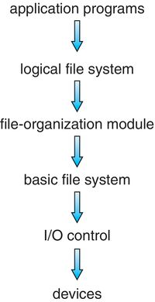

List 4 things that a file system must be able to do:

Select the correct answers:
- Where are files stored in UNIX? (Select 1.) FFS, UFS, ext3, ext4, NTFS, FAT or FAT32
- Where are files stored in Windows? (Select 3.) FFS, UFS, ext3, ext4, NTFS, FAT or FAT32
- Where are files stored in Linux? (Select 2.) FFS, UFS, ext3, ext4, NTFS, FAT or FAT32

Define the following terms related to file systems
- Magic Number:

- shared lock vs exclusive lock on file system:

- Truncating vs. deleting a file:

Why is a file extension the most vulnerable to corruption issues?
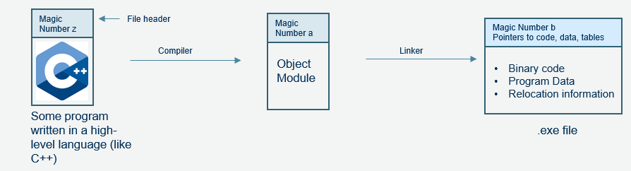

Using the picture below from Windows, square the relative path name and circle the absolute path name for this folder:
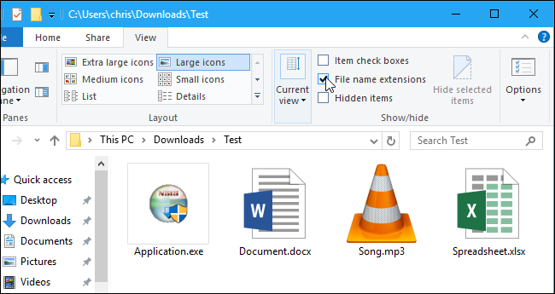

Define the following terms:
File Directory or Folder:
Root:
Relative Path Name:
Absolute Path Name:

 | Acyclic Directory Structure | Tree-structured Directory Structure
Draw a Picture
Define the Term

Define the following terms related to file systems:
- Boot Control Block (BCB):

- File Control Block (FCB):

- Mount Table:

- Master File Table (MFT):

- Bit Vector:

Identify if the following pictures are either Contiguous, Clustered, or Linked allocation and define the term (Hint: Section 13.5 in Zybooks):
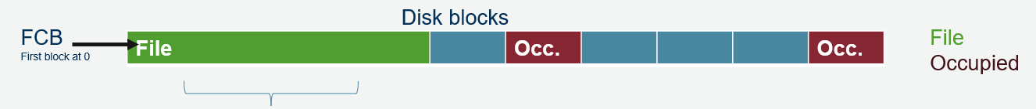
File
Occupied

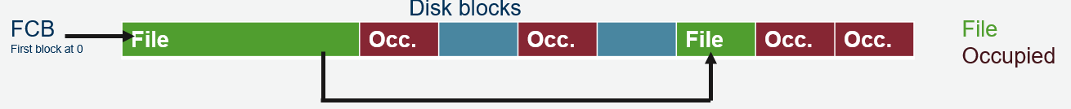

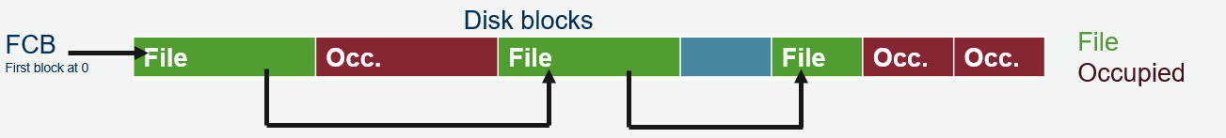

Operation | Describe what happens with the file and FCB
Create File
Destroy File
Open File Table
Open File
Read File
Write
Seek

Which accounts can destroy a file?

How does Windows present a common interface for all system calls to avoid complex per-program coding?

Memory Management
Complete the following table by filling in the blanks of either the term or definition:
Term | Definition
 | No file system is used
Cooked disk
 | Stored in firmware, finds the kernel (by knowing the file system) and starts executing it when the system is powered on
Boot control block (per volume)
Partition Boot Sector
 | Contains volume details (number of blocks, size of blocks, and free block pointers)

What is mounting?

What are the steps for mounting a table?
Step 1:
Step 2:
Step 3:

What is mmount used for within the Linux operating system?

What is memory mapping?

What is memory-mapped I/O?

I/O
Term | Definition
Port
Bus
Daisy Chain
Device Driver
Device Controller

Which is a piece of hardware: device driver or device controller?

Which interacts with the operating system and translates information from the I/O device into genetic system call?

Which storage device is directly connected via a serial bus?

Which two are directly connected to a computer? (Select 2.) Host-attached, iSCI, NAS, or Cloud Storage

Polling vs. Interrupts
Which system call method is like asking “…are we there yet?...” because it is repeatedly checking to see if the /O device is available or busy waiting?

Which system call method only announces itself once it has arrived?

Describe how interrupts work with the interrupt request line and what ‘maskable’ means.

Disk Scheduling
Fill in the following diagram with the following words: Track, Sector, Cylinder, Shaft. Each word may be used more than once.

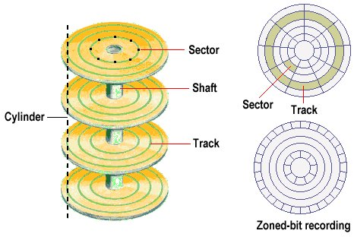
Fill in the terms within the following table:
Term | Definition
 | One or many concentric rings on a magnetic disk surface
 | Smallest portion of a track that can be read or written to via a single r/w operation. Each sector r/w data in blocks.
- Proportional to the distance traveled
- Time to move the r/w from the current position to the track containing the right data
- Proportional to $\frac{1}{2}$disk revolution
- Time to wait for the desired sector/data item to pass under the r/w head
- Proportional to the disk’s speed
- Time to transfer the desired bits to/from the disk
 | Data streamed to or from the disk once the head is at the beginning of the sector to be transferred
 | The rate at which the data can transfer continuously
 | R/W head collides with the platter and causes damage
- Speed changes because the outer edges of the track hold 40% more sectors than the inner tracks
- Maintains transfer rate and density per track
- Maintains speed
- Changes transfer rate

Disk Access Optimization
Assume that the R/W head is at track 50 and needs to go to the following tracks (in no particular order): 0, 10, 55, 70, 100, and 105.

Draw what it would look like under the shortest seek time algorithm:
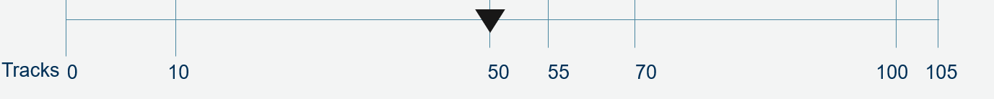
Define the shortest seek time algorithm:

Draw what it would look like under the C-Scan algorithm:
Define the C-Scan algorithm:

Draw what it would look like under the Scan algorithm:
Define the Scan algorithm:

Commonly Used Linux Commands
Complete the following table by filling in the blanks of either the Command name or Command description:
Command Name | Command Description
cat
chmod
 | Displays active processes and system resource usage
cmp
 | Sorts lines of text files or input data
 | Searches for files and directories based on specified criteria
gzip
more
 | Terminates processes by name
 | Displays the username of the currently logged-in user
ifconfig
 | Archives multiple files into a single file

NTFS and EXT File Systems (EXT2, EXT3, EXT4)
What is the main difference between EXT2 and EXT3 file systems?

What feature in NTFS helps ensure file system reliability?

Which Linux file system supports large files and system sizes with features like multiblock allocation?

What is the role of the Master File Table (MFT) in NTFS?

Which Linux file system is recommended for use on flash drives and USB drives?

