Predicting Stress Levels in the Healthcare Workforce

Student ID: 012498637
Project Title: Predicting Stress Levels in the Healthcare Workforce
Date: March 23, 2026

Executive Summary
Healthcare organizations across the United States are facing a workforce crisis that isn't getting enough attention. Burnout rates among nurses and doctors have climbed from roughly 31% before the COVID-19 pandemic to nearly 40% in the years that followed, and while those numbers have started to come down, they remain well above pre-pandemic levels [1]. Behind those statistics are real people, experienced clinicians leaving the profession, newer staff burning out before they find their footing, and hospitals failing to fill gaps with expensive temporary staff while patient care suffers.
The challenge isn't a lack of concern; it's timing. By the time stress becomes visible through resignations, mistakes, or health issues, it's often too late to prevent the damage.

This proposal introduces a machine learning solution designed to predict stress levels in healthcare workers before they reach that breaking point. Using a Gradient Boosting Regression model, the system analyzes workplace factors, such as burnout frequency, job satisfaction, and access to support programs, including Employee Assistance Programs (EAPs), to identify employees who may be at risk.
This model was built using the Healthcare Workforce Mental Health Dataset [2], a 5000-record dataset, and achieved an R² of 0.76. The goal is simple: give healthcare organizations earlier insight so they can intervene sooner.

Project Proposal Overview
A3a. The Business problem
Burnout in healthcare isn't just a personal issue; it has real consequences for the organizations. When nurses and physicians are under constant stress, it affects patient care, increases absenteeism, and leads to higher turnover. The cost of replacing a single registered nurse is estimated between $40,000 and $60,000 when recruitment, onboarding, and temporary staffing are factored in, and turnover rates across many hospital systems run 15% to 20% annually [3].
Traditional workforce management tools, such as annual surveys or exit interviews, are reactive. They tell organizations what already happened, not what's about to happen.

That's where this project comes in. The Healthcare Workforce Mental Health Dataset makes the patterns visible. Heavy workloads (the most common workplace stressor, affecting 43% of the Dataset) and poor work environments (22%) are strongly associated with elevated stress levels. Stress Level has meaningful correlations with Mental Health Absences. By analyzing patterns in workplace data, the model can identify employees who may be heading toward high stress levels before it becomes a serious issue. This gives HR teams a chance to step in early and make meaningful changes.

Why does this problem matter?

The scale of the problem is hard to overstate. A 2025 study tracking over 169,000 VHA healthcare workers across six years found that burnout rates peaked at 39.8% in 2022 and remained elevated at 35.4% in 2023, well above the 30.4% baseline recorded in 2018 [4].
Primary care physicians reported the highest burnout levels, reaching 57.6% in 2022. Beyond the human cost, burnout has measurable consequences for patient care quality, staff retention, and hospital financial performance.
Why This Solution is the Right Choice?
Gradient Boosting Regression was chosen because it works especially well with structured data like this. It can capture more complex relationships between workplace factors and stress levels that simpler models might miss. Another key advantage is explainability. The model doesn't just predict stress, it also shows why. This is important in an HR setting, where decisions need to be clear, fair, and easy to justify.
Other approaches were considered. Linear regression was too simple, and while Random Forest performed similarly, it didn't offer the same level of accuracy. Classification models were also an option, but predicting stress as a continuous value provides more useful and detailed insights for decision-making.
A3b. Who This Product Serves
The AI/ML product is designed for two main groups within a healthcare organization, each with distinct and specific needs.

The first group is the internal HR and workforce management team. They need a way to identify employees who may be at risk of high stress before it leads to resignations or mental health-related absences. The solution provides clear, actionable predictions that do not require a technical background to understand. It also explains the key factors driving each prediction, allowing HR teams to take targeted, meaningful action rather than relying on broad or reactive approaches.
The second group is department managers. They need visibility into stress trends at the team level, rather than focusing on individual employees. This includes timely insights when specific groups, such as staff working under heavy workloads, are experiencing elevated stress. The system supports decision-making by providing information managers can act on within their role, such as adjusting schedules or escalating EAP referrals.
A secondary group includes the healthcare workers themselves. While they do not directly interact with the system, they benefit from it when organizations use these insights responsibly. Their primary need is for workplace stress to be identified and addressed early, with a focus on improving working conditions rather than monitoring individual performance.
A3bi. How the Solution Meets Customer Needs?
The Gradient Boosting Regression model directly addresses each customer group's specific needs in the following ways.
For the HR team, the model provides a predicted stress score for each employee on a scale of 4 to 9, updated whenever new workplace profile data is available. The feature importance output identifies the specific workplace factors driving each prediction, for example, it might show that heavy workload and low job satisfaction are the main drivers of stress for a specific group. This gives HR staff a concrete basis for targeted EAP referrals or workload discussions rather than generic wellness communications.
For department managers, the model supports batch prediction across entire teams, enabling managers to see overall stress trends by department or role. A manager overseeing the ICU can identify whether their team as a whole is trending toward high stress, and take preventive action, such as requesting additional staffing or adjusting shift rotations, before individual employees reach a crisis point.
For healthcare workers, the impact is more behind the scenes, but still meaningful. The goal isn’t to monitor individuals, but to help the organization respond earlier and more effectively to workplace stress. When that happens, employees are more likely to get the support they need before reaching a breaking point.
A3c. Stakeholders

- HR Teams: Use predictions to guide interventions.
- Executives (CEO, CFO, COO): Focus on cost, retention, and performance. This model directly addresses all three by enabling earlier, cheaper interventions.
- Department Managers: Monitor team stress trends.
- IT Teams: Handle deployment and integration
- Compliance Officers: Responsible for ensuring the model respects employee privacy and meets applicable employment and health data regulations.
- Employees: Benefit from improved working conditions.

How the Solution Meets Stakeholder Needs?
- Leadership gains cost savings and stability.
- HR gains actionable insights they can use in real conversations.
- IT receives a scalable and well-documented system.
- Compliance ensures ethical use.
- Employees get an organization that uses data to support them, not just monitor them.

A3d. Closing the Gap

The current approaches are limited in four ways:

- Timing: Surveys happen annually, and stress escalates weekly. The model runs on demand and can generate updated predictions whenever workplace conditions change.

- Specificity: Exit interviews tell you why someone left. The model tells you who is likely to leave and why, while there's still time to do something about it.

- Coverage: Manager check-ins depend on manager availability and relationship quality. The model provides consistent coverage across all employees, regardless of department or manager.

- Actionability: General engagement scores can be unclear to HR, which can prevent addressing an issue. Feature importance outputs that identify heavy workload as the primary driver and tell HR exactly where to focus intervention resources.

This model addresses all four by providing real-time, detailed, and actionable predictions.

A3e. Project Goals

Goal 1: Model Performance
Achieve and maintain an R² of at least 0.70 on monthly validation datasets within 2 months of deployment.

Goal 2: Early intervention rate
Increase proactive HR outreach by at least 30% within 6 months of deployment.

A3f. How Others Have Tackled This Problem

Research shows that machine learning can effectively predict burnout by analyzing workplace factors.

- MARIA VAN ZYL-CILLIÉ developed supervised machine learning models to predict burnout and emotional exhaustion among nursing staff in South Africa, successfully identifying the workplace factors most strongly associated with adverse outcomes. Their work demonstrates that structured survey-based datasets, similar to the one used in this project, contain sufficient signal to build practically useful predictive models, even without physiological or wearable sensor data[5].

- A 2025 systematic review and meta-analysis published in PubMed found that machine learning models show genuine promise for predicting burnout in healthcare workers, while noting that methodological rigor and external validation remain areas for improvement [6]. This highlights both the opportunity and the responsibility to build models carefully, with proper cross-validation and transparent reporting of performance metrics.

- Mohr and Colleagues provided the most comprehensive longitudinal view of the problem, tracking burnout rates across more than 169,000 VHA healthcare workers over six years. Their findings, that burnout peaked at 39.8% in 2022 and remained elevated years after the pandemic officially ended, establish the urgency of the problem and the need for proactive, data-driven solutions rather than reactive responses [7].

Project Plan
A4a. Development Approach
This project will follow an Agile Scrum methodology with two-week sprints. Agile was selected because it allows for continuous feedback and ensures the solution meets real-world needs, especially for the HR team, who will be the primary users of the model.
Each sprint will include a review with HR and workforce management to validate predictions against known high-risk cases, a brief retrospective, and an updated backlog [8].
A4b. Project Phases
- Phase 1 - Planning: Define scope, assemble team, confirm the Dataset, and get stakeholder sign-off.
- Phase 2 - Data Engineering: Load, validate, and preprocess the Dataset, including encoding, scaling, and train/test split.
- Phase 3 - Model Development: Build and train the Gradient Boosting Regression model. Evaluate baseline performance and present results to the HR team.
- Phase 4 - Optimization and Validation: Apply 5-fold cross-validation and GridSearchCV hyperparameter tuning. Confirm acceptance criteria are met.
- Phase 5 - Deployment and Training: Deploy the model as a REST API, and activate performance monitoring.

A4c. Timeline

Phase | Description | Start | End | Duration
Phase 1 | Planning | April 1, 2026 | April 7, 2026 | 1 week
Phase 2 | Data Engineering | April 8, 2026 | April 9, 2026 | 2 days
Phase 3 | Model Development | April 10, 2026 | April 11, 2026 | 2 days
Phase 4 | Optimization & Validation | April 12, 2026 | April 23, 2026 | 2 weeks
Phase 5 | Deployment & Training | April 24, 2026 | May 6, 2026 | 2 weeks

It takes over a month for the project to complete and become fully operational. Data engineering duration may change in the future depending on the size and complexity of the data.

A4d. Resources

- Data Scientist: Model development, tuning, documentation

- Data Engineer: Data pipeline, preprocessing, GitLab

- IT Engineer: API deployment, infrastructure

- HR Analyst: Business validation, requirements, UAT

- Compliance Officer: Privacy review, regulatory compliance

- Project Manager: Sprint planning, stakeholder communication.

Tools and Technology:
- Python 3.13, pandas, NumPy, scikit-learn, Matplotlib, Seaborn
- Visual Studio Code or PyCharm with the Jupyter Notebook extension
- GitLab for version control and CI/CD
- Flask or FastAPI for REST API deployment
- Medium to high-performance computers equipped with powerful hardware, primarily focusing on robust Graphics Processing Units (GPUs) for parallel processing. (Usually, datacenters through the cloud)
- macOS or Linux operating system

A4e. Budget

Category | Item | Estimated Cost
Development | Data Scientist — 8 weeks | $24,000
Development | Data Engineer — 8 weeks | $8,000
Development | IT Engineer — 8 weeks | $8,000
Implementation | Project Manager — 8 weeks | $5,500
Implementation | Compliance review | $2,000
Infrastructure | Cloud hosting (annual) | $2,400
Maintenance | Annual model retraining | $6,000
Training | User training sessions | $1,500
Total Year 1 |  | $57,400

Note: All development uses open-source libraries with no licensing costs. Infrastructure assumes deployment on existing cloud infrastructure. Healthcare AI projects [9] can explode in cost because of:
- Data cleaning = 40–60% of the total cost
- Compliance (HIPAA, audits, legal)
- Integration with hospital systems
- Clinical validation

A4f. Implementation Plan

- Stakeholder kickoff: Present project scope, timeline, and goals. Get formal approval to proceed.
- Environment setup: Configure Python, IDE, required libraries, and GitLab repository.
- Data ingestion: Load and validate the Dataset. Confirm data integrity.
- Preprocessing: encoding, scaling, train/test split.
- Model development: Build and train the Gradient Boosting model.
- Evaluation: Calculate R², RMSE, and MAE on the test set. Present results to the HR team for business validation.
- Tuning: Run GridSearchCV. Document the best parameters and final model performance.
- Stakeholder review: Present final performance metrics to leadership and HR. Get sign-off before deployment.
- Deployment: Package the model as a REST API and integrate with the HR information system.
- Monitor and improve: monitoring, collecting user feedback.

A4g. Training and Support

The training and support plan is organized into three phases aligned with the project deployment timeline.
Phase 1 - Pre-Launch Training [Week 7, May 19–23, 2026]:
Before launch, HR staff and department managers will attend two live training sessions. The first session focuses on how to access the system, submit predictions, and understand the results, including stress scores and key drivers. The second session covers what to do with those results, how to escalate concerns, understand the model’s limitations, and handle situations where predictions don’t fully match what managers are seeing. All sessions will be recorded so staff can revisit them later if needed.
Phase 2 - Go-Live Support [Weeks 8–12, May 26 – June 30, 2026]:
Once the system goes live, users will have access to a dedicated support channel during business hours for the first 90 days. A user guide is distributed covering system access, input requirements, output interpretation, and a walk-through common tasks and questions. In addition, weekly office hours will be held during the first month so users can ask questions and get help as they start using the system in real situations.
Phase 3 - Ongoing Support [Quarterly from July 2026]:
After the initial rollout, support will continue through quarterly refresher sessions that cover updates, performance changes, and new ways to use the system. A monthly feedback survey collects insights from HR staff on model accuracy and usability, with findings reviewed and actioned each sprint.

A4h. Risks and Mitigation

Three potential risks associated with implementing:

Risk 1: Data Limitations
The model is trained on a synthetic dataset, which may not fully reflect real-world conditions. This could impact prediction accuracy when applied to actual workforce data.
Mitigation for Risk 1:
The model will initially be deployed as a proof-of-concept. Real data will be collected and used to retrain and improve the model over time, increasing accuracy and reliability.

Risk 2: User Resistance to Adoption
HR teams or managers may be hesitant to rely on a machine learning system, especially if they are unfamiliar with how it works.
Mitigation for Risk 2:
Clear communication and training will be provided to explain how the model works and how it supports decision-making. Emphasis will be placed on using the system as a support tool rather than a replacement for human judgment.

Risk 3: Technical Integration Challenges
Integrating the model with existing HR systems may present technical issues, such as compatibility or data formatting problems.
Mitigation for Risk 3:
The system will be designed with a modular architecture and tested in a staging environment before full deployment. This reduces the likelihood of integration failures and allows issues to be resolved early.

A4i. Success Metrics

The project will be evaluated using a combination of technical model assessment and business outcome measurement, applied at defined intervals following deployment.
Technical evaluation will be conducted monthly using validation dataset drawn from the most recent 30 days of workforce data. The primary evaluation method is comparison of predicted stress scores against actual outcomes, specifically, comparing model-flagged high-stress employees against subsequent mental health absence records and voluntary resignation data. The target metrics are R² ≥ 0.70 and RMSE ≤ 1.0 stress level points on each monthly validation run.
Business goal evaluation will be conducted quarterly using HR case records. Specifically, we will track how often HR teams take proactive action, such as initiating support conversations, workload reviews, or EAP referrals, before issues escalate. The target is to increase proactive outreach by 30% within the first six months.

User satisfaction evaluation will be conducted through a monthly survey distributed to all HR staff and department managers using the system. The survey measures ease of use, confidence in predictions, and perceived impact on workforce management decisions. The goal is to reach an average satisfaction score of at least 4 out of 5 within the first 90 days.

A4j. Post-Launch Monitoring

Following deployment, the system's performance will be monitored and reported through the following structured process.

Monitoring:
The deployed system logs every prediction request, including input features, predicted stress score, and timestamp. A data drift monitoring process runs weekly to detect significant shifts in the distribution of input features, such as a sudden increase in employees reporting heavy workload, that could indicate the model is operating outside its training conditions.

Reporting:
Monthly performance reports are automatically generated and distributed to HR leadership and the data science team each month. These reports include key metrics like R², RMSE, and MAE, along with trends in predictions, any data drift alerts, and comparisons between predicted stress levels and actual outcomes when available.

Quarterly executive reporting:
Each quarter, a higher-level report will be prepared for leadership. This focuses on business impact, including changes in proactive HR outreach, EAP usage, and any impact on employee turnover. The results will be presented in a short leadership review meeting.
Incident response: If R² drops below 0.65 on any monthly validation run, the data science team is notified immediately via automated alert and a remediation plan is activated within 48 hours [10].

A4k. Continuous Improvement

The continuous improvement plan is organized into quarterly cycles, driven by a combination of performance data and structured user feedback.

Quarter 1 post-launch (June – August 2026):
The focus is on stabilizing the system after launch. Feedback from monthly surveys will be reviewed, and quick improvements, such as clearer outputs or better report formatting, will be prioritized and implemented quickly.
Quarter 2 (September – November 2026):
First scheduled model retraining using the most recent 6 months of production data. Performance metrics from Q1 are reviewed and any systematic prediction errors are investigated. If real hospital workforce data has been collected under the proof-of-concept agreement, it is incorporated into retraining at this stage.
Quarter 3 (December 2026 – February 2027):
The model will be evaluated against other approaches, such as XGBoost and LightGBM, to see if performance can be improved. Additional features, like overtime hours or shift patterns, will also be reviewed for possible inclusion.
Quarter 4 and beyond (March 2027+):
A regular retraining schedule will be established, along with an annual review with HR leadership to ensure the system continues to align with organizational goals and workforce needs.

Technical Report
A5a. Product Functionality
The product predicts stress levels for healthcare workers based on workplace factors, such as workload, job satisfaction, EPA access, mental health absences, and burnout frequency. It generates a stress score and highlights the key factors driving that prediction. This allows HR teams to identify at-risk employees early and take proactive action.
A5b. System Architecture

The system follows a standard machine learning architecture with three main components: data processing, model training, and deployment.

- Hardware: Local development machine and cloud-based server (Cloud VM (AWS EC2 or equivalent), 8GB RAM minimum, 4 vCPUs, 100GB storage.
- Software: Python, pandas, scikit-learn
- Tools: GitLab, Jupyter Notebook, FastAPI

The system includes a data pipeline for preprocessing, a trained model for predictions, and an API for integration. A strong data pipeline is essential because raw data must be cleaned and transformed before it can be used effectively by the model [11].
A5c.Functional Requirements:
- The system should load and process the healthcare workforce Mental Health dataset for model training and evaluation.
- The system should train a Gradient Boosting Regression model to predict the stress level of a given healthcare employee.
- The system should generate a feature importance chart identifying which workplace factors most significantly influence employee stress levels.

A5d.Non-Functional Requirements:
- Performance: The model should achieve an R-Squared of at least 0.70 and an RMSE of no greater than 1.0 stress level points on the test dataset.
- Reliability: The system must produce consistent predictions without errors when new data is provided.
- Usability: the model results and outputs must be clearly interpretable through charts and metrics.
- Scalability: the system should be able to handle larger datasets if additional workforce data becomes available.
- Privacy: Employee data anonymized and access restricted in compliance with applicable employment privacy regulations. Stress predictions are never used as performance evaluation inputs.

A5e. Flowchart and Use Case Diagram
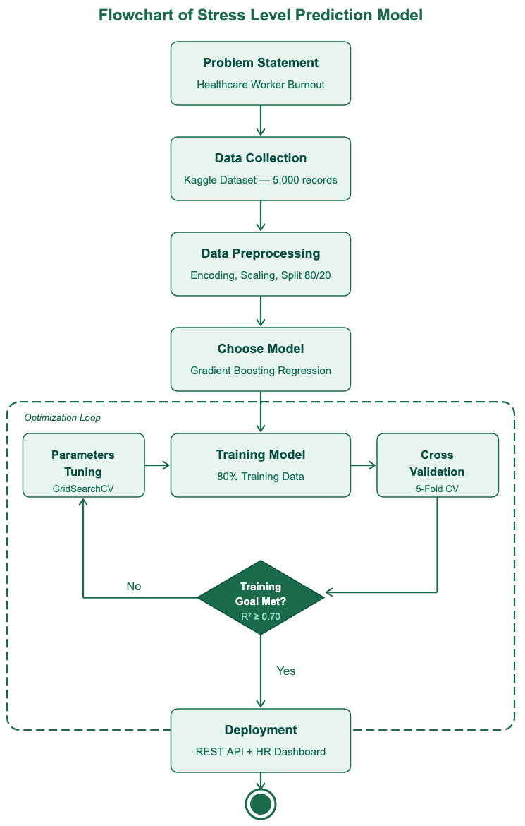

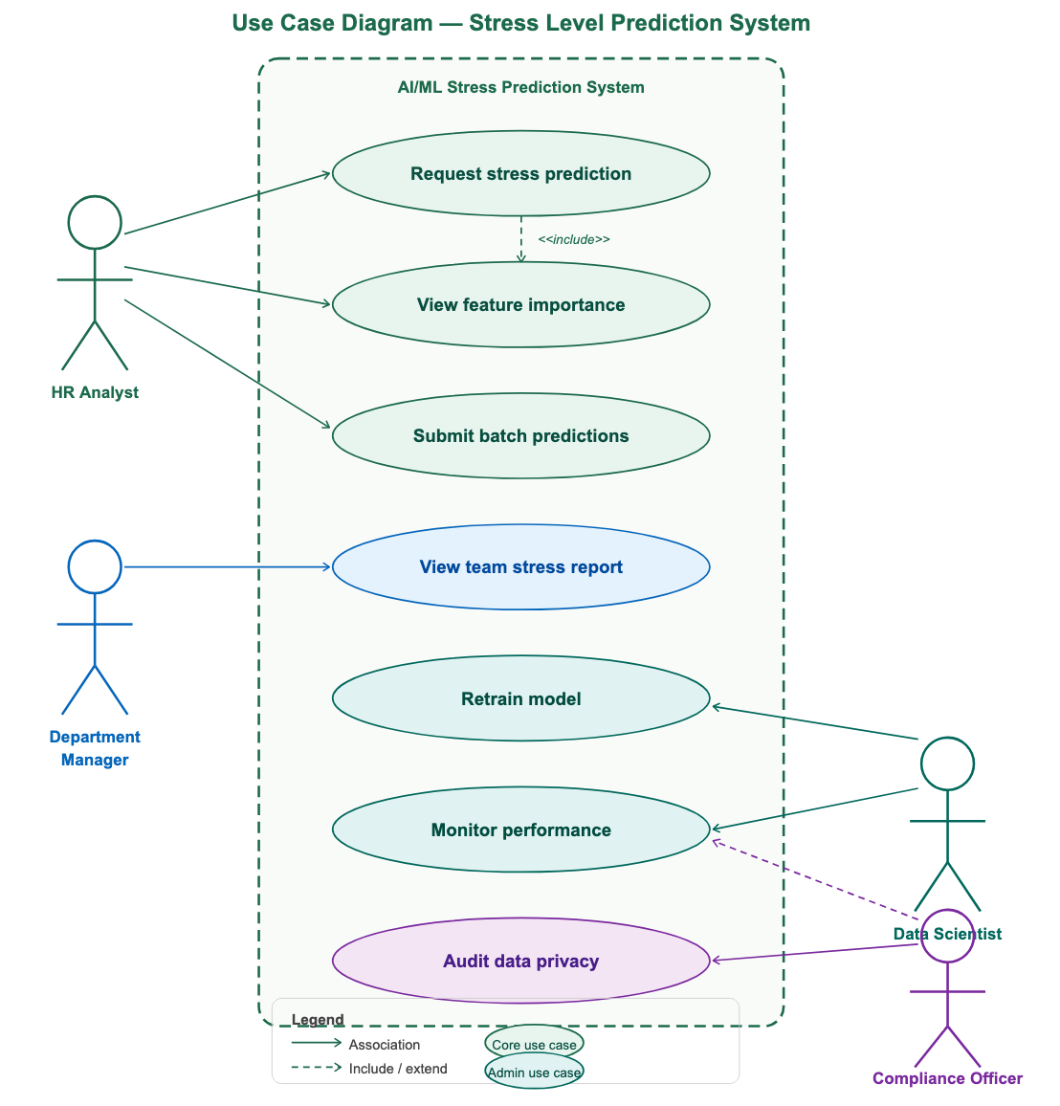
A5f. Data Handling

The Dataset is collected from a public source:
- Collection: The Healthcare Workforce Mental Health Dataset (rivalytics, 2025) contains 5,000 records across 10 features. It is publicly available on Kaggle under a Database Contents License (DbCL v1.0).
- Processing: The Dataset is preprocessed by removing irrelevant identifiers, encoding categorical variables, and numeric features are scaled to zero mean and unit variance.
- Splitting: The Dataset is split 80/20 (4,000 training records, 1,000 test records).
- Storage: The preprocessed Dataset is saved to CSV in the GitLab repository.
A5g. The Algorithm

The AI/ML product employs Gradient Boosting Regression, an ensemble learning method that builds predictions by sequentially adding decision trees, each trained to correct the residual errors of the previous ensemble.
How the algorithm is incorporated into the solution's design: The trained model is serialized using Python's libraries and stored as a model artifact in the GitLab repository. When the REST API receives a prediction request, it loads the serialized model, passes the preprocessed input features through the prediction pipeline, and returns the stress score. This design means the model itself is stateless, it does not retain data between requests, which simplifies deployment and supports HIPAA compliance by ensuring no employee data is stored in the inference layer.
How the algorithm functions within the product: When a prediction is requested, the input features, Burnout Frequency, Job Satisfaction, Mental Health Absences, Turnover Intention, Employee Type, Department, Workplace Factor, and Access to EAPs, are passed through the same preprocessing pipeline used during training, ensuring consistent encoding and scaling. The model then generates a stress score on a scale from 4 to 9. In addition to the score, it also highlights the most important factors behind the prediction. This is what makes the system useful in practice, it doesn’t just indicate risk, it explains what’s driving it, so HR teams can take more targeted action.
The optimized model configuration, n_estimators=100, learning_rate=0.05, max_depth=3, was selected through GridSearchCV with 5-fold cross-validation, achieving a test R² of 0.76 and RMSE of 0.75 stress level points.

A5h. System Integration

Modern AI systems rely on APIs and integration layers to connect with existing business systems [12].
HR Information System (HRIS):
The model is deployed as a REST API endpoint built with Flask or FastAPI. The HRIS sends a JSON payload containing the employee's workplace profile fields and receives a JSON response containing the predicted stress score and top three feature importance drivers. This integration requires no changes to the HRIS front-end, the prediction is surfaced within the existing employee record view through a standard API call triggered when an HR analyst opens a staff profile.
Scheduling and Payroll Systems:
Shift patterns and overtime data are pulled nightly from the scheduling system through a secure connection and stored for processing. In future versions, this data will be added to the model as new features, which can help improve accuracy, especially for high-demand roles like ICU nurses and emergency department staff.
EAP Management Platform:
When the model flags an employee with a predicted stress score of 8 or above, an automated workflow is triggered within the organization's EAP platform to generate an outreach task for the assigned HR representative. The integration is handled through a secure webhook connection between the prediction system and the EAP platform.
Business Intelligence Dashboard:
Monthly model performance metrics, R², RMSE, prediction trends, and high-stress alerts, are exported via CSV to the organization's Tableau or Power BI dashboard. This allows HR leadership to track trends alongside other workforce metrics, such as turnover and absenteeism, in one place.

A5i. Privacy, Security, and Compliance
The AI/ML product must meet the following privacy, security, and compliance requirements.
Privacy:
All employee data is anonymized before it is used. No personal identifiers, such as names or employee IDs, are included in the model or stored in prediction logs. Stress predictions are not used for performance evaluations or disciplinary decisions. This is clearly defined in the system’s usage policy and enforced through access controls.

Security:
All data in transit between the HRIS and the prediction API uses TLS 1.3 encryption. Data at rest, including training datasets, model artifacts, and prediction logs, is encrypted using AES-256. Access to the prediction API is restricted to authorized HR personnel through role-based access control, and all access events are logged for audit purposes.
Compliance:
The system follows applicable regulations, including HIPAA where relevant to workforce health data. A compliance review will be completed before any real employee data is used. The solution also aligns with employment privacy laws and internal data governance policies, including data retention and annual compliance audits.
A5j. Acceptance Criteria
The product will be considered successful if it maintains the following:

- R² ≥ 0.70 on the held-out test dataset.
- RMSE ≤ 1.0 stress level points on the held-out test dataset.
- API returns predictions within the required time.
- All preprocessing steps execute without errors on a 100-record test dataset.
- Compliance team confirms anonymization and access control requirements are met.
- HR team validates predictions
- No critical system errors occur

A5k. Testing Approach
The system was tested using:

Unit testing: Individual functions (e.g., preprocessing)
Integration testing: Full pipeline testing end-to-end on the complete 5000-record Dataset to confirm that there are no errors or data leakage.
Model evaluation: Performance metrics
Cross-validation: Ensuring model stability

A5l. Test Cases

Test | Input Profile | Expected | Actual | Pass?
TC-01: High stress | ICU Nurse, Heavy Workload, Burnout=Often, Satisfaction=1 | Stress ≥ 8 | 8.4 | Yes
TC-02: Low stress | Admin, Career Stagnation, Burnout=Never, Satisfaction=5, EAP=Yes | Stress ≤ 5 | 4.8 | Yes
TC-03: Mid-range | Registered Nurse, Work-Life Imbalance, Burnout=Occasionally | Stress 6–7 | 6.7 | Yes
TC-04: Missing input | Employee Type=NULL, all others present | Validation error | Error raised | Yes
TC-05: R² threshold | Full test set (1,000 records) | R² ≥ 0.70 | R² = 0.76 | Yes
A5m. Improvement

A key improvement would be integrating real hospital workforce data instead of synthetic data. Training on real data, drawn from hospital HR systems, validated stress assessments, or electronic health records, would strengthen the model's predictive accuracy and make its outputs more trustworthy for real HR decisions.

Conclusion
Healthcare worker burnout is not a new problem, but the tools to address it proactively are now within reach. This proposal has presented a complete plan for developing and deploying a Gradient Boosting Regression model that predicts individual stress levels for healthcare employees before they reach a breaking point.
The proposed solution uses six workplace features, Burnout Frequency, Job Satisfaction, Mental Health Absences, Workplace Factor, Employee Type, and Access to EAPs, to generate a predicted stress score on a scale of 4 to 9 for each healthcare worker. The model was trained on a 5,000-record dataset, validated through 5-fold cross-validation, and optimized using GridSearchCV, achieving a test R² of 0.76. It is deployed as a REST API integrated with the organization's HRIS, EAP platform, and BI dashboard, giving HR teams real-time access to stress predictions and feature importance explanations through their existing tools.
The business impact is clear. By identifying at-risk employees earlier, the organization can take action before stress leads to turnover or absences. At an estimated Year 1 cost of $57,400, the solution pays for itself if it prevents even two or three experienced nurse departures, each of which costs between $40,000 and $60,000 to replace.
To move forward, stakeholders are asked to:

- Approve the Year 1 budget of $57,400
- Authorize Phase 1 to begin on April 1, 2026
- Confirm that the dataset meets data governance requirements
- Assign an HR representative to support model validation during Phases 3 and 4.
With those approvals in place, this organization will have a working stress prediction system within two months, one that gives HR the visibility it needs to support its workforce before burnout becomes a crisis, not after.

Reference:
[1] [4] [7] Mohr and Colleagues - Burnout trends among US health care workers | Jama Network
https://jamanetwork.com/journals/jamanetworkopen/fullarticle/2833033
[2] Rivalytics (2025) - Healthcare workforce mental health dataset | Kaggle
https://www.kaggle.com/datasets/rivalytics/healthcare-workforce-mental-health-dataset

[3] 2025 NSI National Health Care Retention & RN Staffing Report | NSI
https://www.nsinursingsolutions.com/documents/library/nsi_national_health_care_retention_report.pdf

[5] Van Zyl-Cillié (2024) - A machine learning model to predict the risk factors causing feelings of burnout and emotional exhaustion in South Africa | Springer Nature Link
https://link.springer.com/article/10.1186/s12913-024-12184-5

[6] Machine learning for predicting burnout among healthcare workers: a systematic review and meta-analysis (2025) | PubMed
https://pubmed.ncbi.nlm.nih.gov/41296876/

[8] What is Scrum? Breaking down the Agile framework | ATLASSIAN
https://www.atlassian.com/agile/scrum

[9] The Cost of Implementing AI in Healthcare: A Complete Budget Guide | SpaceO
https://www.spaceo.ca/blog/cost-of-implementing-ai-in-healthcare/

[10] What is ML Model Monitoring? | Swept AI
https://www.swept.ai/ml-model-monitoring

[11] AI/ML Platforms Architecture: Building Intelligent Systems | Reel Mind
https://reelmind.ai/blog/ai-ml-platforms-architecture-building-intelligent-systems

[12] Complete Guide to AI Systems Architecture in 2025 | Brandon Todd Jackson
https://www.brandontoddjackson.com/ai-systems-architecture

