WGU's Four-Step Tool (based on "Six Steps to Thinking Systemically" by Michael Goodman and Richard Karash)
The Iceberg Tool is a way to see how the underlying structure causes the individual events and the patterns or trends that emerge from recurring events. Using the Iceberg Tool allows you to see the basic facts and interconnections, an important first step.
STEP 1: Complete an Iceberg Tool for this case study.

Iceberg Tool to Understand Patterns and Structure
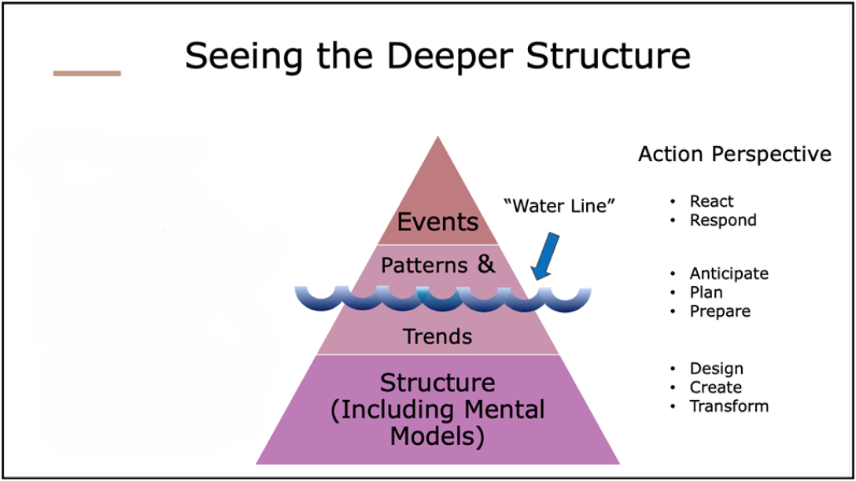

Questions to Ask
- What are the key events in this case study?

- What patterns do you notice in the key events of this case study?

- What structure(s) explain the patterns of events in this case study?

The BOT Graph helps you identify how behaviors play out over time; here, the time is the period in which the case study occurred. It is best to group similar events or patterns together in a graph; for example, you might create one BOT Graph showing the actions of different team members (all actions) and another for the investments made in marketing campaigns and the resulting return on those investments (all money).
STEP 2: Complete at least one Behavior Over Time (BOT) Graph by drawing and clearly labeling one or more lines representing key patterns in your selected case study. (You can use the Drawing Tools in Word to create the lines on the template provided below.)
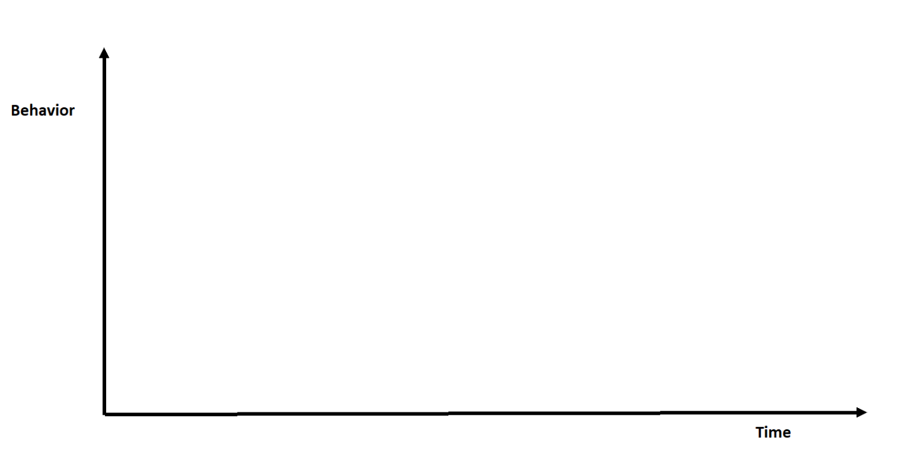
Remember to label or describe the behavior(s) depicted in your BOT Graph(s) above.

STEP 3: Select the systems archetype that best fits the case study. You may wish to refer to A Pocket Guide for Using the Archetypes.
The value of the eight systems archetypes is that they represent common systemic problems. If you can find an archetype that fits the system and the problem(s) you are confronting, you can use established ideas to deal with the problem(s).
Examine each archetype carefully, comparing its causal loop diagram and text description with the given case study to see which one is the best fit.
- Which archetype did you select?

- Why does this archetype best fit the given case study? Explain how its causal loop diagram and text description match up with the facts of the case study.

- What is the main problem that needs to be addressed in this case study?

STEP 4: Generate a solution to the problem.
Systems thinking is a mindset and a process focused on identifying and solving problems. Without problems, there is little need to think systemically. In this step, you consider a full range of possible solutions and select the best one.
- What do you propose would be the best solution for the problem in this case study?

- What are the strengths of this solution?

- What are the challenges of this solution?

- What other alternatives did you consider? (Identify at least one reasonable alternative solution.)

- Why is your proposed solution, from Step 4, Question 1, superior to each of the alternatives identified in your response to the previous question?

- What do you project the impact of your proposed solution will be on the overall system described in this case study?

