Introduction to Systems Thinking and Applications - D459 Performance Assessment.
TASK 1 - Applying Systems Thinking Basics

Student Name: Zakaria Benmoulay
Student ID: 012498637
Course: Introduction to Systems Thinking and Applications — D459
Submission Date: DEC 3, 2025

Project Overview:
This submission provides a systems thinking analysis of the Wilde's Bramble case study, examining how an organic farm business experienced financial crisis despite growing market success.

Case Study 1: The Wilde’s Bramble

Using the Iceberg Tool, we identified the following:

A.1: Key events:

- Alder and Calla’s high quality and organic products gain popularity at local farmer’s markets, which leads local shops and restaurants to show interest and purchase their goods.
- As demand grew, pressure to produce more grew as well, leading the Alder and Calla to expend their productions by leasing more farmland and investing in new equipment which led to additional operation costs.
- To manage the financial pressure, they start using credit cards, Calla had to get a different job to help with cash flow, and they even took out a mortgage on the farm but they were still overwhelmed with the increase of debts, threatening the business’s long-term sustainability.

A.1: Key Patterns:
- The Wilde’s high-quality organic products gained popularity, causing high demand which led to the increase in production costs.
- The expansion of their business operations resulted in more financial pressure, pushing the couple to find different means to get cash, a mortgage, causing more debt.
- Sales rates grew fast, and operation expenses grew even faster, outpacing the revenue growth, leading the couple to financial difficulties.

A.1: the underlying structure that causes the identified events and patterns to occur:
The Wilde’s approach to the business growth was short sighted, as demand increased, they expended their production without a long-term upscaling plan. To cope with the production and expansion costs, the Wilde relied on short-term fixes such as credits cards, taking out a mortgage on the farm and Calla taking and different job which led to a long-term debt and vulnerability.

A.2: Selection of Behavior Over Time Graph
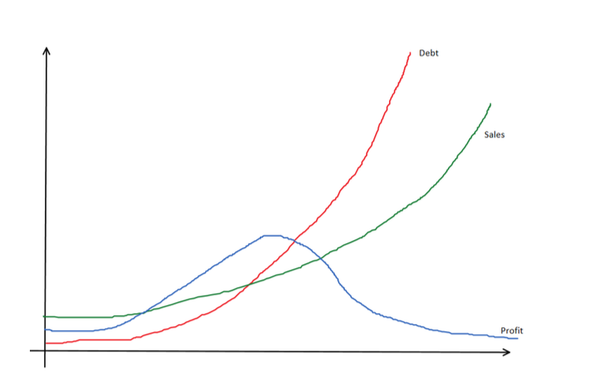

Graph #2 is the correct representation of the Behavior Over Time for the Wilde’s case. It shows the three trends over time: sales increasing, debt increasing and profits rising then declining over time, which align with events of the Wilde’s Bramble case.
At the start of the Wilde’s business growth, more sales meant more profits, show in green and blue lines in the graph, but also meant soar in demand which led to production expansion. While the expansion is a good step for a growing business, the Wilde’s plan was inefficient and short sighted, using temporary fixes, such credit cards, mortgage on the farm (debt) which is represented with a red line in the graph, growing exponentially over time, overwhelming the revenue rates, leading the profits to decline as show in the graph as well.

A.3: Analysis of the Wilde’s case:

The Iceberg Tool and the Behavior Over Time (BOT) graph revealed that the Alder and Calla faced a structural financial vulnerability caused by a mismanaged growth strategy rather than a simple budgeting issue. While demand and sales increased, the underlying system driving their business was imbalanced, meaning, while their production and expansion costs rose immediately, the revenue flow lagged behind. This delay pushed the Wildes to rely on short-term fixes such as credit cards, mortgage and different means to get cash flow into their business. The BOT graph confirms that while sales surged due to their high-quality products, the profit rates went up at first, but start to decline, indicating that the business was not generating enough revenue to cover the costs, leading the Wildes to cope with debts, shown in red increasing through time. Putting all these events, patterns and the underlying structural causes together, concludes that the real problem for the Wildes was their approach to meeting market demand without implementing a long-term sustainable strategy.

Respectfully submitted,

Zakaria Benmoulay
012498637
Nov 27, 2025

