Introduction to Systems Thinking and Applications - D459 Performance Assessment.
TASK 2 - Application of System Thinking

Student Name: Zakaria Benmoulay
Student ID: 012498637
Course: Introduction to Systems Thinking and Applications — D459
Submission Date: DEC 4, 2025

Project Overview:

This submission contains an analysis of the Middlesex County homelessness crisis using the Fixes that Fail system archetype, showing how temporary solutions provided by the county government unintentionally worsen the crisis even more.

Case Study: Middlesex County Homelessness Problem

A1. Case Study Analysis Using Systems Archetype:

The system archetype Fixes that FAIL best describes the ongoing homelessness situation in Middlesex County. Fixes that fail occurs when we apply a quick fix (short-term) to a problem, providing an immediate relief which temporarily reduces the symptoms but fails to address the root cause in the long-term. In the Middlesex County Homelessness example, the county government relied on temporary shelters (QUICK-FIXES) to address homelessness (the PROBLEM), which create a sense of helping people off the streets, leading to a false perception among the public that homelessness is being solved (UNINTEDED CONSEQUENCE). This perception ultimately reduces the public support for a long-term solution such as affordable housing programs that would address the root cause of the original problem, causing the crisis to worsen even more.

A2. Diagram Template:
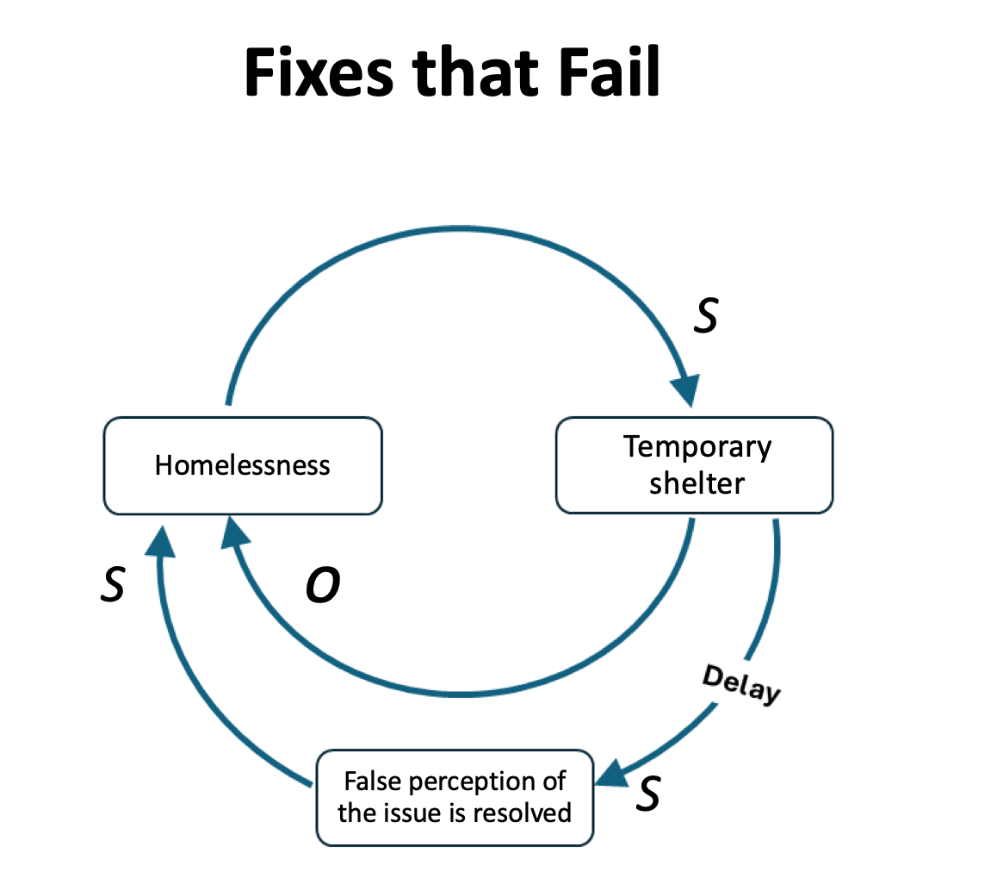

This Fixes that Fail diagram shows accurately describe the homelessness situation in Middlesex County. As the crisis increases, the county provides more temporary shelters. The shelters create the delay effect that lead the people of Middlesex county to believe that the issue is resolved, causing less and less support for a real and a long-term solutions, which ultimately leads to more and more homelessness.
A3. Summary of the Problem:

The Middlesex County’s approach failed to address the root causes of homelessness by providing short-term solutions to an increasingly serious issue. Temporary shelters reduce the number of unhoused people on the street, which create the illusion of solving the problem, reducing the public pressure to support and invest in affordable housing programs that would address the real cause of Homelessness, which ultimately increases and worsens the crisis in Middlesex County.

The Fixes that FAIL archetype reveals a self-defeating cycle:
- Homelessness (Problem) manifest in Middlesex County.
- The county implements temporary solutions (quick fixes)
- The temporary relief creates the false perception of the issue is resolved. (Unintended consequences)
- This perception reduces the public concern regarding the support of a long-term solution such as affordable housing programs.
- As a result, the root cause remains unaddressed, allowing the crisis to persist or even worsen over time.

Respectfully submitted,

Zakaria Benmoulay
012498637
Nov 27, 2025

