Introduction to Systems Thinking and Applications - D459 Performance Assessment.
TASK 3 - Application of System Thinking

Student Name: Zakaria Benmoulay
Student ID: 012498637
Course: Introduction to Systems Thinking and Applications — D459
Submission Date: DEC 6, 2025

Project Overview:
This submission uses the Four-Steps Systems Thinking Tool and examines YumYum’s operational decline during the rapid growth. Using the Iceberg tool, Behavior Over Time and systems Archetype, we reveal how an uncalculated growth to a business can lead overwhelm the whole operation.

A1. Four-Step Systems Thinking Analysis of YumYum (Clickbait Cuisine Case):

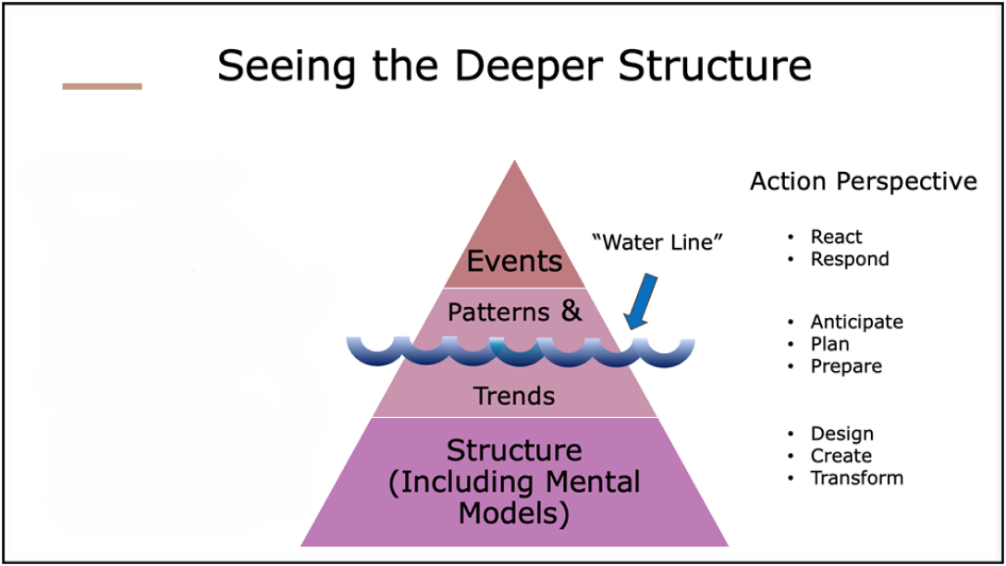

STEP 1: Complete an Iceberg Tool for this case study

Key events:
Using the Iceberg Tool we can see that:

- YumYum’s user base grew rapidly.
- Lack or shortage of delivery drivers and customer service staff.
- Longer delivery times.
- Overwhelmed drivers made mistakes.
- Unsatisfied customers left negative reviews tainting their reputation.
- Customers started to use competitors services
- Revenue declined
- Lenders reduced financial support

Patterns:

A clear pattern emerges after analyzing this case:
Initially, YumYum’s user friendly app and diverse restaurant options attracted a significant share of customers leading to a rapid growth of user base following a performance decline. As a result, customer service problems grew, triggering a negative feedback from frustrated customers which reinforced YumYum’s declined reputation and revenue, limiting the ability to improve their services.

Structures:
The underlying structure is a reinforcing growth loop facing a balancing constraint. As YumYum gained more users, the number of orders increased, which initially boosted revenue and growth. This success put a lot of stress on the system leading to a capacity limits, because they failed to invest in the necessary operational personnel. Not enough drivers or customer service representatives, causing longer delays and errors, ultimately leading to the decline of YumYum’s services and revenue. This decline triggers the balancing loop; poor services results customer loss, and ultimately a decline in YumYum’s revenue.

STEP 2: Complete at least one Behavior Over Time (BOT) Graph by drawing and clearly labeling one or more lines representing key patterns in your selected case study
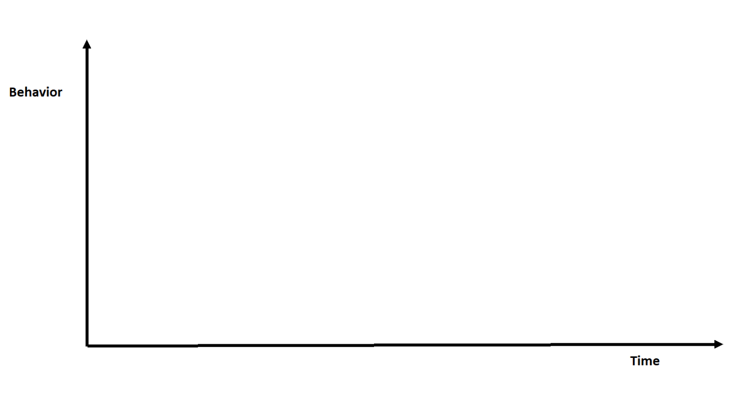

User Base
Revenue
Service Quality

STEP 3: Systems Archetype

- Archetype selected: Growth and Underinvestment
- Why this archetype fits:
The Growth and Underinvestment archetype describes exactly YumYum’s situation, consistent growth in demand combined with insufficient reinvestment in capacity. YumYum’s performance degraded over time because it didn’t invest in enough drivers and support staff while user base grew. As a result, the poor service, delays and errors overcome the growth aspect of the company. Therefore, Growth-and-Underinvestment best matches the causal loop dynamics of this case: a reinforcing demand loop hit a balancing limit because capacity was underfunded.
- Main Problem to Address:
The main problem with YumYum is that they prioritized user growth without matching the operational capacity (staffing), creating a structural imbalance that caused service quality to decline, leading to customer loss, revenue decline, and inability to recover.
STEP 4: Generate a solution to the problem
- What do you propose would be the best solution for the problem in this case study?
Proposed Solution: With revenue generated from the initial growth, expand staffing and delivery resources to meet demand. Using the operational and user trend data at hand, create a clear performance metrics and growth thresholds that automatically triggers hiring events for delivery drivers and customer service representatives before reaching capacity limits. To maintain high service quality, periodic refresher and training courses should be implemented for customer service staff. These fundamental solutions fix the underlying capacity problem rather than a temporary patch.

- What are the strengths of this solution?
Strengths of this solution: The solution proposed addresses the root cause of YumYum problem. Investing in staff using data and metrics would reduce the delivery time issues, errors due high demand and improve customer service satisfaction. Quick and high-quality service result in happy customers, and help grow the user base and revenue, breaking the negative reinforcing loop. This solution also builds long-term resilience with sustainable growth model in place.

- What are the challenges of this solution?
Challenges of this solution: The main challenge of the proposed solution would be the funds to and resources to hire and train more staff while the revenue is slowing down, which may require looking into external funding, or even loans. In addition, this will also take time to train the new drivers and staff in the recruiting process.
- What other alternatives did you consider? (Identify at least one reasonable alternative solution.)
Other alternatives considered: Outsourcing delivery services or partnering with third party delivery companies such UberEAT, DoorDash to boost capacity without going through the hiring and training process. Another alternative is raising prices while keeping the high-quality service to generate more revenue and invest in the long-term solutions like expanding capacity.
- Why is your proposed solution, from Step 4, Question 1, superior to each of the alternatives identified in your response to the previous question?
Why the proposed solution is superior: Focusing on long-term solution like expanding capacity is superior because it tackles the real root cause of the problem rather than just the symptoms of the problem. Raising prices may work as a temporary solution as your user base may look for a cheaper alternative. If you outsource delivery services, you lose control of that branch but equally to blame if things go wrong. The proposed solution is a long-term solution that deal with the real problem, it prevents the negative reinforced loop and enables the reinforcing growth loop to function again.
- What do you project the impact of your proposed solution will be on the overall system described in this case study?
Projected system impact: If we implement the solution successfully, YumYum overall services will improve, lower waiting delivery times and less orders errors leads to a high customer satisfaction. Over time, reputation recovers and revenue increases, leading to a stable financial outcome. In systems terms, the balancing loop caused by underinvestment would be weakened or removed, as capacity increases, the limiting effect is reduced, shifting YumYum from a negative spiral to a positive growth trajectory, recovering their reputation, with strong market position.

Respectfully submitted,

Zakaria Benmoulay
012498637
Nov 27, 2025

